
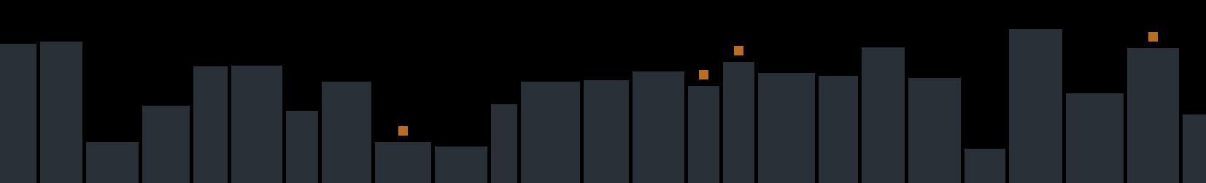
Arden University
Machine Learning (COM7022)
Assessment cover sheet


Clustering eBay Men's Fragrance Listings
Product Segmentation Project and Critical Report

Awarding body | Arden University
Module | Machine Learning (COM7022)
Assessment title | Clustering eBay Men's Fragrance Listings: Product Segmentation Project and Critical Report
Student number | 25174056
Tutor | Ahmed Hassan
Word count | 2,812 words (main text, excluding tables, references and appendices)
Submission | Wednesday, 18 November 2026

Table of Contents
Task 1: Machine Learning Project 3
1.1 Data import and preparation 3
1.2 Statistical investigation 3
1.3 Feature selection and transformation 3
1.4 Clustering models 5
1.5 Model evaluation and selection 7
1.6 Cluster profiles and business relevance 8
Task 2: Critical Report 10
2.1 Purpose 10
2.2 Key findings 10
2.3 Suitability of the methods and features 10
2.4 Comparison of the models 10
2.5 Choice of the final model 10
2.6 Recommendations 11
2.7 Limitations and improvements 11
2.8 Conclusion 11
References 12
Appendix A: Screenshot evidence of the Python processes and results 13
Appendix B: Python code (COM7022_clustering_executed.ipynb) 22
Appendix C: Project files 28
List of Figures
Figure 1: Distributions of price, units sold and stock before and after log transformation 4
Figure 2: Correlation of the log-transformed features and fragrance type counts 4
Figure 3: K-Means elbow curve, silhouette and Davies-Bouldin index for k = 2 to 10 5
Figure 4: Ward dendrogram (last 30 merges) 6
Figure 5: DBSCAN k-distance plot 6
Figure 6: K-Means, Ward and DBSCAN clusters on the first two principal components 7
Figure 7: Price, units sold and stock by K-Means cluster 9
Figure 8: Price against units sold, coloured by K-Means cluster 9
Figure A1: Importing the CSV file and inspecting data quality 13
Figure A2: Cleaning the data 14
Figure A3: Descriptive statistics, skewness, outliers and correlation 15
Figure A4: Comparing feature sets A and B 15
Figure A5: K-Means evaluation for k = 2 to 10 16
Figure A6: Hierarchical clustering evaluation 16
Figure A7: DBSCAN parameter search 17
Figure A8: PCA explained variance and loadings 17
Figure A9: Model comparison and stability checks 18
Figure A10: Profiles of the K-Means clusters 19
Figure A11: Robustness check on the imputed stock values 20
Figure A12: Diagnostics for feature sets A and B 20
Figure A13: Sensitivity of the clusters to imputed and censored stock 21
Figure A14: Observed silhouette compared with null data 21
Figure A15: Concentration of estimated sales value 21

Task 1: Machine Learning Project

1.1 Data import and preparation
The dataset holds 1,000 eBay men's fragrance listings captured on 22 to 24 May 2024, with 10 variables including price, units sold, stock available, a category label and seller location. I imported the CSV with pandas (McKinney, 2010) and inspected it before changing anything (Figure A1). There is no outcome to predict, so this is an unsupervised problem and accuracy does not apply. There were no duplicate rows, but values were missing in available (111 rows, 11.1%), lastUpdated (53), sold (8) and price (5), and the category column, spelt "Catatory" in the file, held 63 spellings of a few fragrance types.
Five decisions shaped the preparation (Figure A2). First, the sold column contradicted the listing text once ("Last One / 6 sold" records 7,654 sales), so I took units sold from the text and used the column as a fallback. Second, five missing prices were recovered from the displayed price string. Third, three Canadian-dollar listings were removed rather than converted at an unknown rate; with rows still missing price or sold, 991 listings remain. Fourth, stock came from the numeric column or the text ("Last One" counts as 1). Of 64 listings with no usable stock number, 3 were in the removed rows and the other 61 were imputed with the median (9): 59 saying only "Limited quantity" and 2 "More than 10 lots". A further 295 listings (29.8%) show "More than 10 available", so their stock is recorded as 10 but is a lower bound (censored); section 1.5 tests the effect. Fifth, I merged the 63 category spellings into four groups: Eau de Toilette (456), Eau de Parfum (310), Other (157) and Cologne (68).

1.2 Statistical investigation
After cleaning, the typical listing costs $35.68 (median), has sold 50 units and shows a stock of 9, but the means are $46.15, 768 units and 18.5: the data are right-skewed (skewness 1.96 for price, 9.77 for sold, 8.61 for available; Figure A3). By the 1.5 × IQR rule 135 sold values (13.6%) are outliers, the largest being 54,052 units. I kept them as genuine high-volume listings and handled the skew by transformation. Location varies little (92.8% United States). Correlations between the log features are modest (sold and available 0.45, price and sold −0.15, price and available −0.18; Figure 2).

1.3 Feature selection and transformation
I selected price, units sold and stock available, which describe positioning, demand and supply. I excluded the free-text description, lastUpdated (three days), location (little variation) and brand name (246 values, many used once); brand and fragrance type describe the clusters afterwards. All three features were log(1 + x) transformed and standardised so that dollars and unit counts carry equal weight.
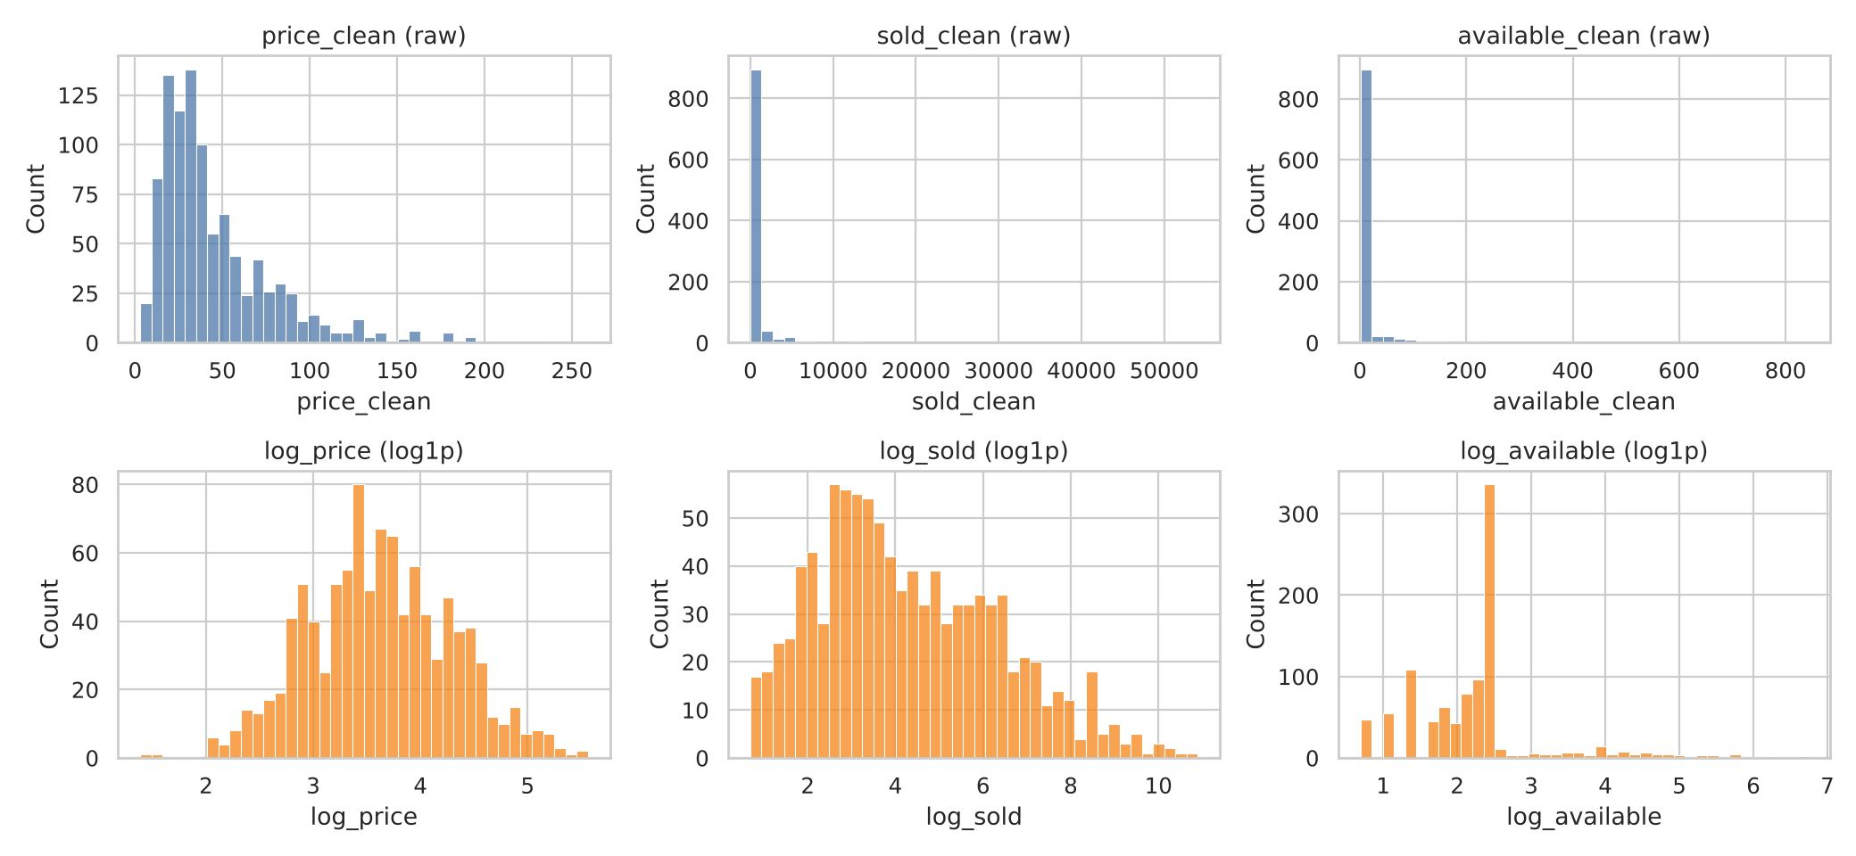
Figure 1 (distributions). Raw price, sold and stock pile up near zero with long right tails. After the log transformation price is close to symmetrical (skewness 0.09) and sold falls from 9.77 to 0.53; stock stays skewed (1.58) because many listings sit at the 10-unit display ceiling.
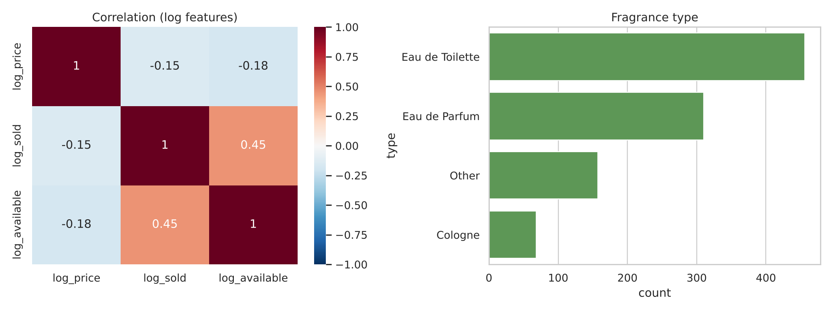
Figure 2 (correlation and type). The only noticeable correlation is between units sold and stock (0.45). Eau de Toilette is the largest fragrance type (456 of 991 listings), followed by Eau de Parfum (310).
Set B (numeric features plus one-hot fragrance type) gave a K-Means silhouette of 0.459 at k = 4 against 0.309 for set A (numeric only; Figure A4). These scores cannot be compared directly, because silhouette is measured in each solution's own feature space, so I scored both in the same space (Table 1, Figure A12). With equally weighted type columns the B clusters are exactly the four fragrance types (adjusted Rand index 1.000), so 0.459 shows only that the labels differ from each other, not anything about price, sales or stock. Scored on those three features, the B clusters have a silhouette of −0.029, against 0.309 for A. Down-weighting the type columns moves B back towards A (adjusted Rand index 0.947 at weight 0.25) and lowers its own silhouette (0.272), and B is less stable over 30 random starts (mean adjusted Rand index 0.886, minimum 0.668, against 0.969 and 0.948). Fragrance type is also almost unrelated to the set A clusters (0.023). I therefore clustered on set A and used type to describe the clusters.
Table 1: K-Means (k = 4) with and without fragrance type, scored in the same space
Feature set | Silhouette (own space) | Silhouette on price, sold, stock | ARI vs fragrance type
A: numeric only | 0.309 | 0.309 | 0.023
B: type columns at weight 0.25 | 0.272 | 0.309 | 0.031
B: type columns at weight 0.5 | 0.224 | 0.301 | 0.055
B: type columns at weight 1 (equal) | 0.459 | -0.029 | 1.000

1.4 Clustering models
I compared K-Means (Lloyd, 1982), Ward hierarchical clustering (Ward, 1963) and DBSCAN (Ester et al., 1996), scored with silhouette (Rousseeuw, 1987), Davies-Bouldin (Davies and Bouldin, 1979) and Calinski-Harabasz (Caliński and Harabasz, 1974) measures. All used scikit-learn (Pedregosa et al., 2011) with random seed 42.
K-Means groups listings around k centres by minimising within-cluster variance. It suits compact, roughly round groups in standardised data and scales well. I ran k = 2 to 10 with 20 starts each (k-means++ seeding; Arthur and Vassilvitskii, 2007) and chose k from three measures, not the elbow alone (Figure A5).
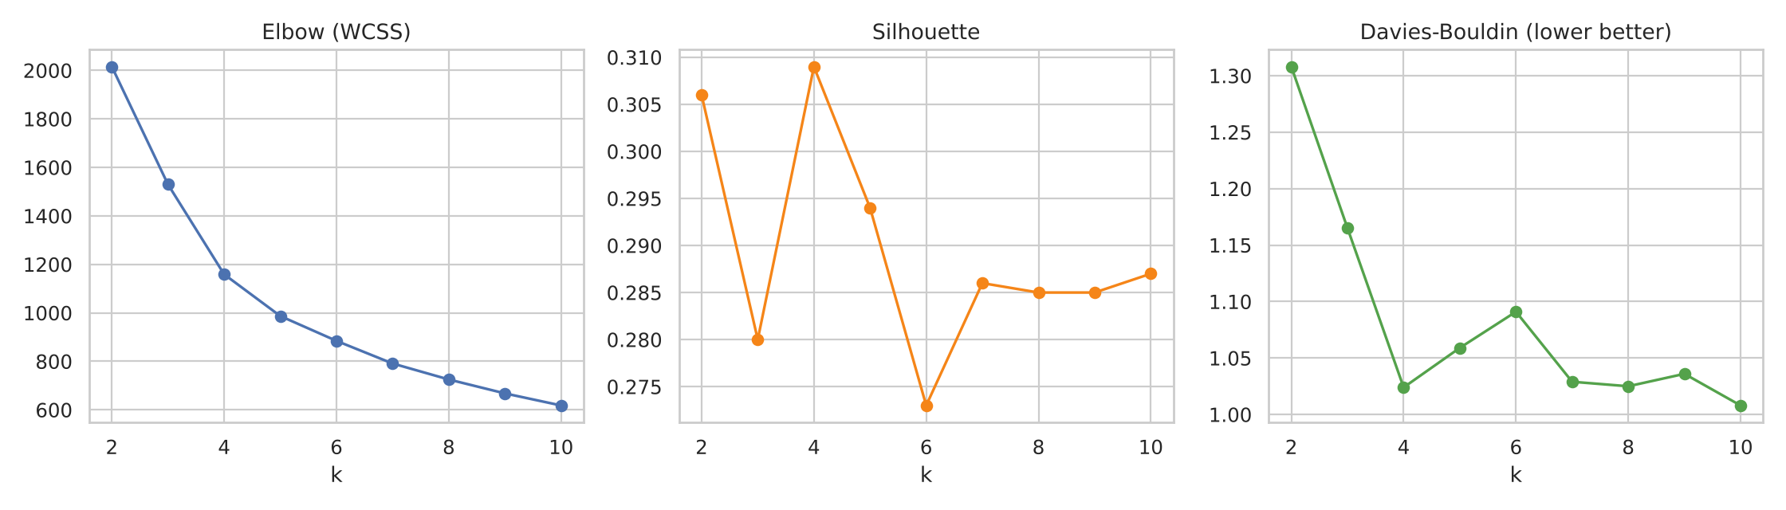
Figure 3 (choosing k). The elbow curve has no sharp bend, so it cannot settle k alone. Silhouette is narrowly highest at k = 4 (0.309), Calinski-Harabasz peaks at k = 4 (515.1), and Davies-Bouldin is 1.024 at k = 4, close to its lowest value (1.008 at k = 10). A silhouette of 0.31 is modest and indicates overlapping groups; section 1.5 tests whether it reflects real structure.
Hierarchical clustering merges the two closest clusters step by step, so k need not be fixed in advance. I used Ward linkage, which shares K-Means' objective (least increase in within-cluster variance), and also tested average and complete linkage (Figure A6). Average linkage scored higher on silhouette at k = 3 (0.397) but gave clusters of 906, 82 and 3 listings, so its score came from isolating outliers.
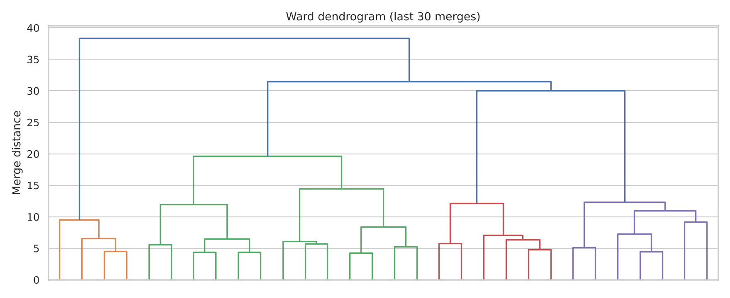
Figure 4 (dendrogram). The dendrogram shows listings merging into larger groups as distance grows. Ward at four clusters gives silhouette 0.268, Davies-Bouldin 1.096 and Calinski-Harabasz 429.9. Two clusters score best (0.440, 0.808) but are too coarse to guide decisions, so I kept k = 4 for a like-for-like comparison and report k = 2 for reference.
DBSCAN joins densely packed points and labels isolated points as noise. It needs no k but depends strongly on eps and min_samples. I set min_samples to 6, twice the number of features (a rule of thumb discussed by Schubert et al., 2017), used the k-distance plot to guide eps, and searched eps from 0.2 to 1.0 with min_samples of 4, 6, 10 and 15 (Figure A7).
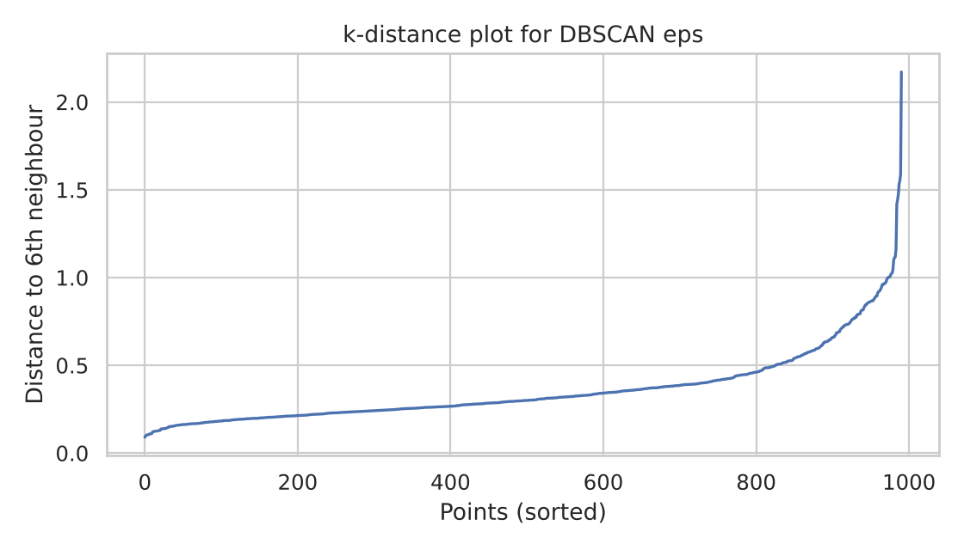
Figure 5 (k-distance). The 90th and 95th percentiles of the sixth-neighbour distance are 0.63 and 0.82, so I chose eps = 0.6. At eps of 0.3 or below, 25% to 93% of listings became noise, while eps = 0.8 merged nearly everything into one cluster of 970. eps = 0.6 gives two clusters (880 and 49 listings) and 62 noise points (6.3%), which are high-volume listings (median 571 units sold against 45 for the rest).
PCA (Jolliffe and Cadima, 2016) shows the clusters in two dimensions. The first two components explain 51.6% and 30.2% of the variance (81.8% together; Figure A8). PC1 is driven by sold (0.65) and stock (0.66), and PC2 by price (0.92). I used PCA for visualisation only.
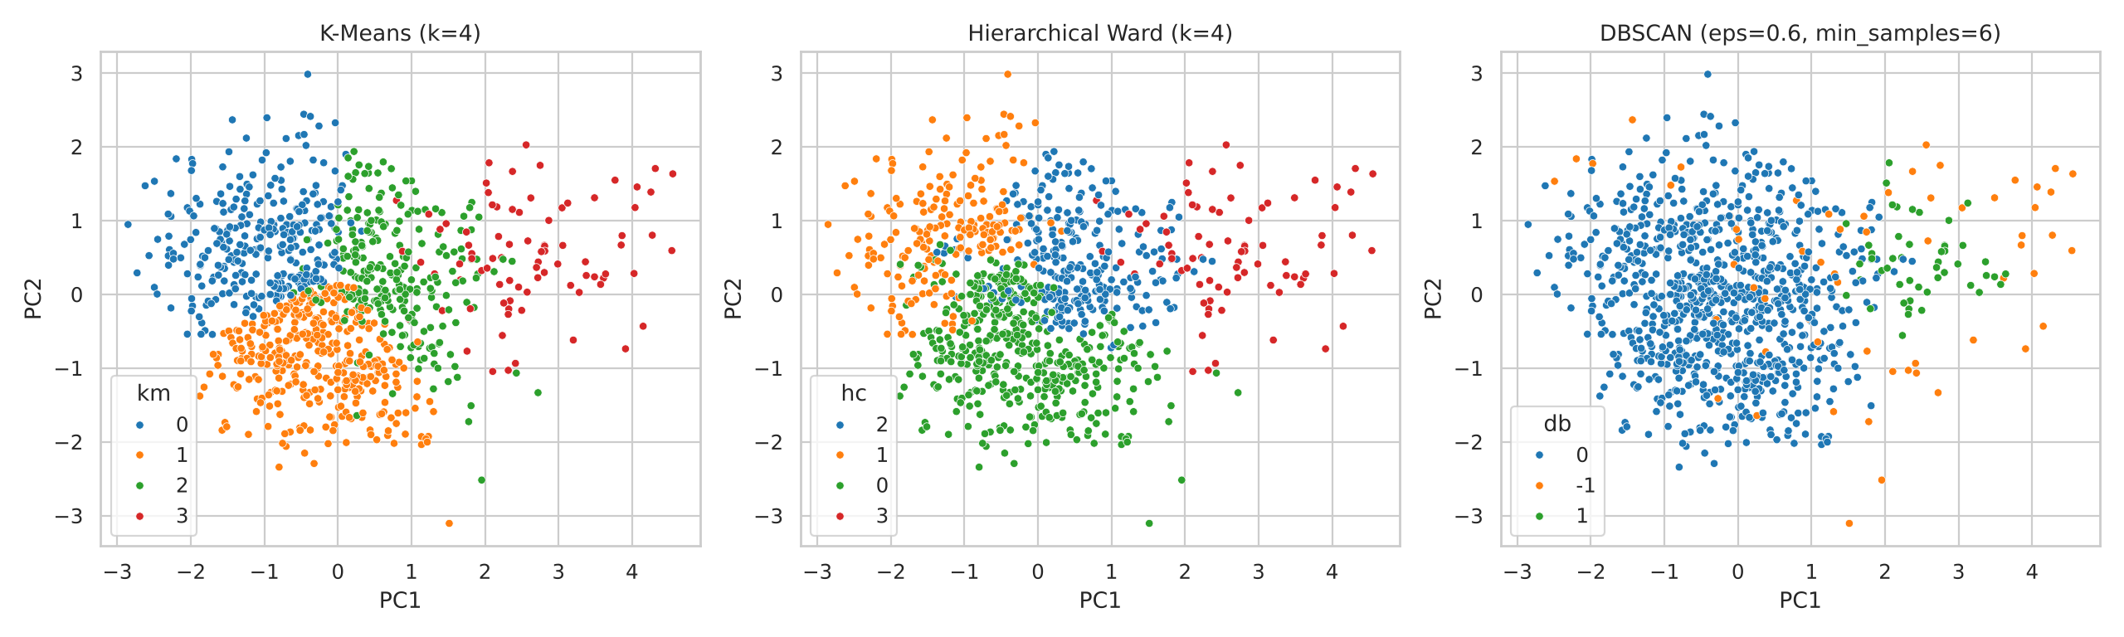
Figure 6 (clusters in PCA space). K-Means cuts the cloud into four overlapping regions, with the high-volume group at the right and price separating the upper and lower groups. There are no empty gaps between regions, so the data look like a continuum, not isolated islands. Ward gives a similar picture with different group sizes (441, 271, 199 and 80 listings); DBSCAN shows one dense mass with its noise points on the right-hand edge.

1.5 Model evaluation and selection
Table 2: Internal validation scores (higher is better for silhouette and Calinski-Harabasz, lower for Davies-Bouldin)
Model | Clusters | Noise % | Silhouette | Davies-Bouldin | Calinski-Harabasz
K-Means (k = 4) | 4 | 0.0 | 0.309 | 1.024 | 515.1
Ward hierarchical (k = 4) | 4 | 0.0 | 0.268 | 1.096 | 429.9
Ward hierarchical (k = 2) | 2 | 0.0 | 0.440 | 0.808 | 326.1
DBSCAN (eps 0.6, min_samples 6) | 2 | 6.3 | 0.398 | 0.750 | 183.8

Silhouette and Davies-Bouldin favour DBSCAN and two-cluster Ward, but both need care. DBSCAN's scores exclude its 62 noise points and describe one large mass plus a small group, and Calinski-Harabasz ranks it lowest (183.8). Among solutions with a usable number of groups, K-Means beats Ward on all three measures. The adjusted Rand index (Hubert and Arabie, 1985) between K-Means and Ward is 0.571, and between either and DBSCAN only 0.09 to 0.10 (Figure A9).
K-Means is stable: over 30 random starts the mean adjusted Rand index against the reference solution is 0.969 (minimum 0.948), and over 30 resamples of 80% of the data it is 0.941 (minimum 0.769).
Stock is the weakest feature (Table 3, Figures A11 and A13). First, 61 values are imputed, 46 of them in cluster 2; re-fitting on the 930 listings with known stock gives an adjusted Rand index of 0.881, and any imputed value from 1 to 20 moves at most 3.4% of listings. Second, and more important, 295 listings (29.8%) show only "More than 10 available" (124 in cluster 1, 106 in cluster 2, 65 in cluster 0), so their true stock is unknown above 10. If they held 15 units, 3.6% of listings would change cluster; at 25 or more, about a third would (adjusted Rand index about 0.5). The segments therefore depend on the display cap and do not measure real inventory.
Table 3: Sensitivity of the K-Means clusters to the stock assumptions (main result: censored = 10, imputed = 9)
Stock assumption | Listings changing cluster | ARI vs main result
'More than 10' listings assumed to hold 10 (imputed = 9) | 0.0% | 1.000
'More than 10' listings assumed to hold 15 (imputed = 9) | 3.6% | 0.899
'More than 10' listings assumed to hold 25 (imputed = 9) | 33.3% | 0.504
'More than 10' listings assumed to hold 50 (imputed = 9) | 32.9% | 0.487
Imputed listings assumed to hold 1 (censored = 10) | 2.7% | 0.928
Imputed listings assumed to hold 5 (censored = 10) | 0.5% | 0.986
Imputed listings assumed to hold 20 (censored = 10) | 3.4% | 0.906

A silhouette of 0.31 cannot show by itself that real clusters exist, so I compared it with 200 simulated datasets of the same size (Figure A14). One correlated Gaussian cloud gave a mean silhouette of 0.241 (maximum 0.264), below the observed value. But shuffling each column independently, which keeps the skewed shapes and the pile-up at the stock ceiling but removes all relationships, gave a mean of 0.293 (95th percentile 0.303, maximum 0.306), only just below 0.309. Much of the score therefore comes from the shapes of single variables, not from groups in the combined space. The evidence for natural segments is weak, so I treat K-Means as a practical partition of a continuum.
I selected K-Means with k = 4: it has the best scores among models with a workable number of segments, is stable, and its groups differ clearly on price, volume and stock. This is a choice of a useful partition, not a finding that four natural groups exist. DBSCAN remains useful as a separate flag for unusual high-volume listings.

1.6 Cluster profiles and business relevance
Table 4: Profile of the K-Means clusters (estimated sales value = price × units sold)
Cluster | Listings | Share | Median price | Median sold | Median stock | Share of est. sales value
2: Core high-volume | 249 | 25.1% | $34.84 | 550 | 10 | 78.4%
3: High-volume, deep stock | 84 | 8.5% | $26.92 | 964.5 | 82.5 | 15.0%
0: Premium, low-volume | 294 | 29.7% | $74.88 | 21 | 6 | 5.4%
1: Budget, low-volume | 364 | 36.7% | $24.39 | 20 | 8 | 1.2%

Core high-volume (cluster 2): 249 listings (25.1%), median price $34.84, 550 units sold, an estimated 78.4% of sales value; 63% Eau de Toilette. High-volume, deep stock (cluster 3): 84 listings (8.5%) at $26.92, 964.5 units sold and a stock of 82.5; 15.0% of value; entirely US-based. Premium, low-volume (cluster 0): 294 listings (29.7%) at $74.88 but 21 units sold; 5.4% of value; the most Eau de Parfum (48%) and non-US listings (15.6%). Budget, low-volume (cluster 1): 364 listings (36.7%) at $24.39 and 20 units sold; 1.2% of value; 28 of the 39 "Unbranded" listings. The names come from these medians, and "volume" means cumulative units sold: listing age is not recorded, so no group can be called a fast or slow seller. Value is also concentrated (Figure A15): the 10 largest listings, all in cluster 2, hold 33.2%, and without them cluster 2 still holds 67.6%.
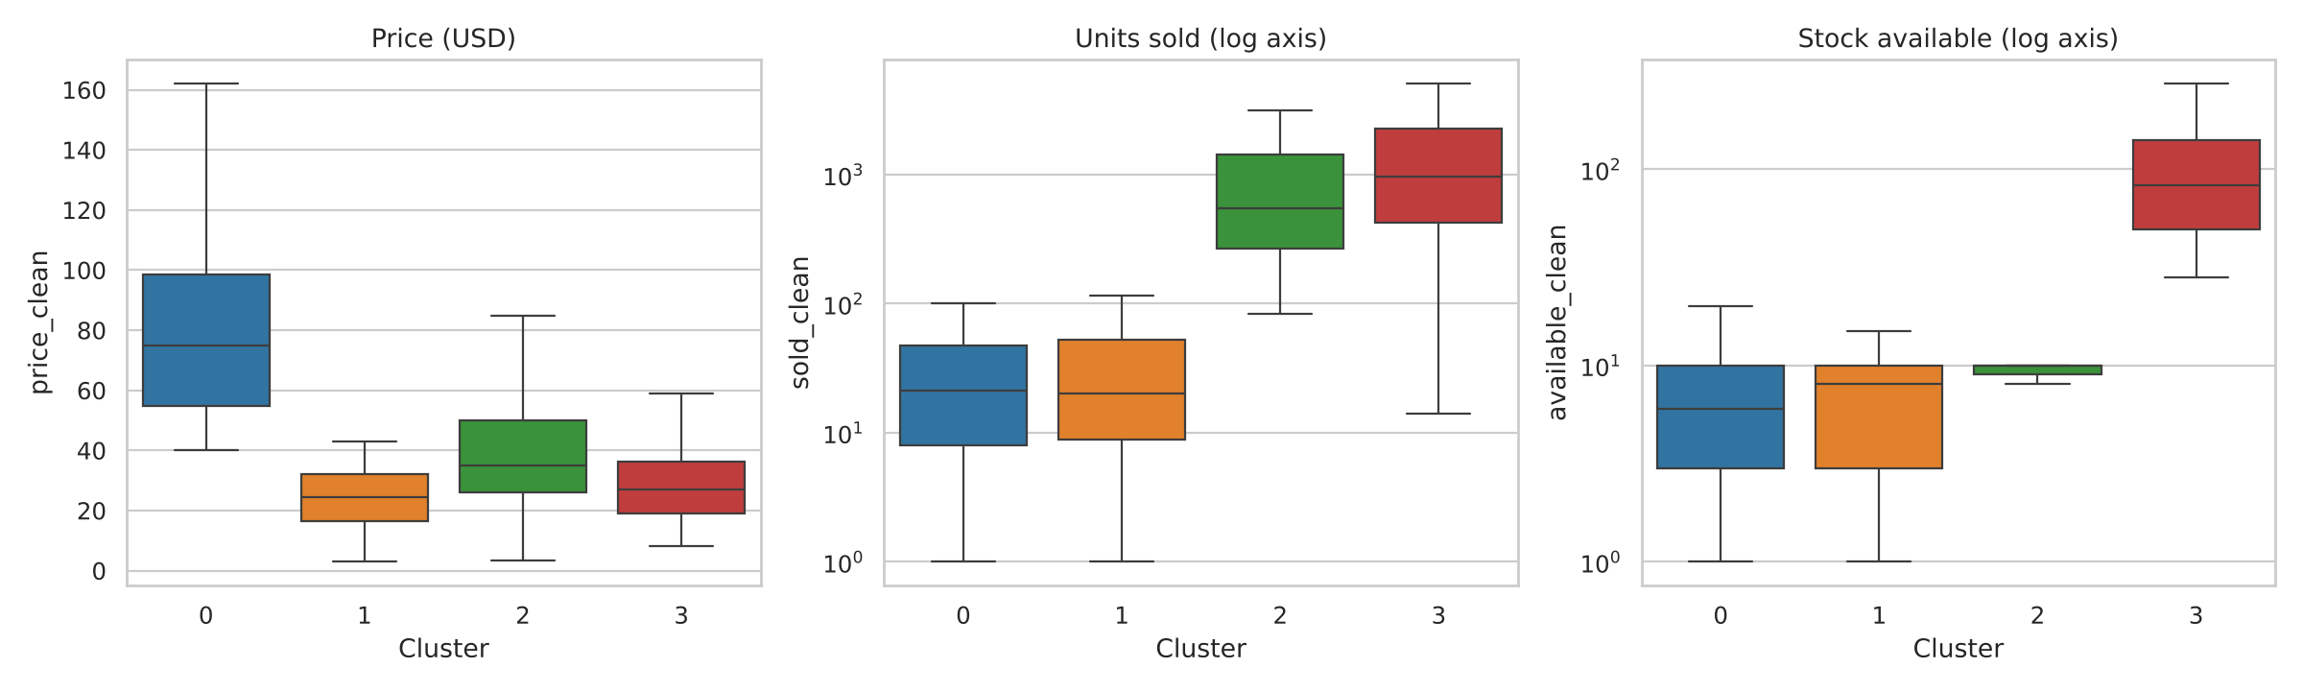
Figure 7 (cluster profiles). Price separates cluster 0 from the rest, units sold separate clusters 2 and 3 (medians 550 and 964.5) from clusters 0 and 1 (21 and 20), and stock separates cluster 3. Cluster 2's stock box is narrow because 70% of its listings show 9 or 10 units (the "more than 10" display or my imputed value).
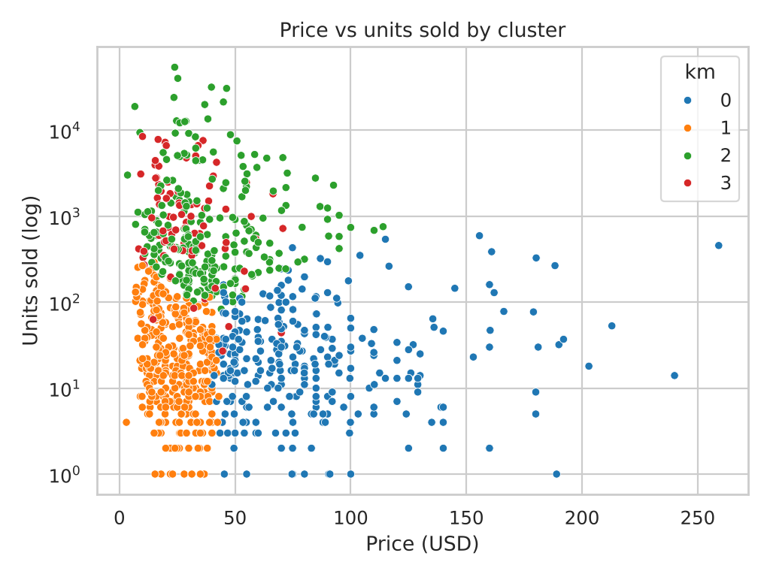
Figure 8 (price against units sold). Cluster 0 sits at the lower right (high price, low volume), clusters 2 and 3 at the upper left, and cluster 1 at the bottom left. The groups overlap, so listings near a boundary could belong to a neighbouring segment.

Task 2: Critical Report

2.1 Purpose
This report sets out what 991 eBay men's fragrance listings show about pricing, sales and stock, and what managers could do about it. Figure references are to Task 1.

2.2 Key findings
• Cumulative sales are concentrated. One quarter of listings (core high-volume) hold an estimated 78.4% of sales value; 36.7% (budget, low-volume) hold 1.2%. The 10 largest listings hold 33.2%, and without them the core group still holds 67.6%.
• High price does not go with high cumulative sales. Premium, low-volume listings have the highest median price ($74.88) but 21 units sold and 5.4% of value.
• Deep stock goes with volume, not price. The 84 high-volume listings hold a median stock of 82.5 at $26.92.
• The segments are a useful partition, not proven natural groups. K-Means and Ward agree moderately (0.571) and K-Means is stable (0.969), but its silhouette (0.31) is close to that of shuffled data (0.29).
• DBSCAN adds an outlier view. It flags 62 listings (6.3%), median 571 units sold, as unusual.

2.3 Suitability of the methods and features
With no outcome to predict, clustering was the right family of methods, and the three features (price, sales, stock) map onto range decisions. The log transformation mattered most, because a handful of listings sell tens of thousands of units. Adding fragrance type gave a higher silhouette (0.459 against 0.309), but it only reproduced the four fragrance labels: scored on price, sales and stock, those clusters were worse than random (−0.029). The highest score should not be followed blindly.
In plain terms, the scores ask how snugly each listing sits in its own group. Ours is about 0.3 and shuffled data score almost as high (0.29), so the segments are a practical way of dividing a continuum, not clearly separate groups.

2.4 Comparison of the models
• K-Means. Strengths: best scores among usable solutions, very stable (0.969), balanced groups. Limitations: k must be chosen in advance, it assumes compact groups, and the groups overlap.
• Ward hierarchical. Strengths: no k needed upfront, a dendrogram shows structure, moderate agreement with K-Means. Limitations: lower scores at k = 4; the best-scoring k = 2 is too coarse.
• DBSCAN. Strengths: finds unusual listings without a preset k. Limitations: found essentially one large mass, depends heavily on eps, and its scores ignore noise points.

2.5 Choice of the final model
I chose K-Means with four clusters for technical and business reasons together. It had the strongest Calinski-Harabasz and Davies-Bouldin results among four-group solutions, and its segments barely changed across random starts or resamples (minimum agreement 0.77). It gives four groups of useful size (8.5% to 36.7% of listings) that managers can name. Two-cluster Ward scored higher on some measures but two segments cannot support separate pricing or stock decisions, and DBSCAN's single mass does not segment the catalogue.

2.6 Recommendations
1. Keep the core high-volume listings in stock, after checking real stock. They hold most of the estimated value, but 106 of the 249 show only "more than 10 available", so true stock is unknown. Check it before setting reorder levels.
2. Review the high-volume, deep-stock group. A median $26.92 with large stock may tie up cash if margins are thin, but high cumulative sales may also reflect a long listing life. Check margin, holding cost and listing age first.
3. Test, do not cut, the premium, low-volume group. Trial selective promotion of well-known brands or a smaller range, judged by margin, since a high price may carry a high profit per unit.
4. Review the budget, low-volume group before any clearance. Its 1.2% share of estimated value shows neither profit nor age: new listings have had little time to sell, and a cheap item can still be profitable or bring in customers. Consider clearance or delisting only for listings that are old, unprofitable and slow, once listing date and unit cost are known.
5. Add the missing data first. Record listing start date, unit cost and actual stock, then compare sales per month and profit per listing for 20 to 30 listings per segment before changing prices or stock.

2.7 Limitations and improvements
Listing age is the main limit on interpretation. Units sold are cumulative since each listing began, so the high-volume groups may simply hold the oldest listings and the low-volume groups the newest; a listing that sold 550 units over several years may sell less now than one that sold 100 in a month. The segments describe accumulated sales, not current demand.
Uncertain stock and estimated sales value affect decisions directly. Stock is capped at 10 for 29.8% of listings and imputed for 61, so reorder or clearance rules based on stock would understate depth for some listings, and if the capped listings hold 25 or more units about a third of listings would change segment. Estimated sales value multiplies today's price by lifetime sales, so it ignores past price changes and discounts and measures revenue, not profit: a thin-margin item can look valuable and a high-margin item weak, which could point pricing decisions the wrong way. Ten listings also hold 33.2% of it.
The data are a three-day snapshot from one marketplace, the sold column contained at least one error, and a silhouette of 0.31 means boundary listings could belong to a neighbouring segment. If repeated, I would add listing age, unit cost and actual stock, repeat over several periods, and compare a Gaussian mixture model with soft memberships.

2.8 Conclusion
A small group of listings carries most of the catalogue's cumulative sales. K-Means with four clusters gave a useful, stable division of the range, though the evidence for natural segments is weak. The recommendations are conditional: listing age, unit cost and actual stock are needed before they become firm pricing, stock or delisting decisions.

References
Arthur, D. and Vassilvitskii, S. (2007) ‘k-means++: the advantages of careful seeding’, Proceedings of the 18th Annual ACM-SIAM Symposium on Discrete Algorithms, pp. 1027–1035.
Caliński, T. and Harabasz, J. (1974) ‘A dendrite method for cluster analysis’, Communications in Statistics, 3(1), pp. 1–27.
Davies, D.L. and Bouldin, D.W. (1979) ‘A cluster separation measure’, IEEE Transactions on Pattern Analysis and Machine Intelligence, PAMI-1(2), pp. 224–227.
Ester, M., Kriegel, H.-P., Sander, J. and Xu, X. (1996) ‘A density-based algorithm for discovering clusters in large spatial databases with noise’, Proceedings of the 2nd International Conference on Knowledge Discovery and Data Mining (KDD-96), pp. 226–231.
Hubert, L. and Arabie, P. (1985) ‘Comparing partitions’, Journal of Classification, 2(1), pp. 193–218.
Jolliffe, I.T. and Cadima, J. (2016) ‘Principal component analysis: a review and recent developments’, Philosophical Transactions of the Royal Society A, 374(2065), 20150202.
Lloyd, S.P. (1982) ‘Least squares quantization in PCM’, IEEE Transactions on Information Theory, 28(2), pp. 129–137.
McKinney, W. (2010) ‘Data structures for statistical computing in Python’, Proceedings of the 9th Python in Science Conference, pp. 56–61.
Pedregosa, F. et al. (2011) ‘Scikit-learn: machine learning in Python’, Journal of Machine Learning Research, 12, pp. 2825–2830.
Rousseeuw, P.J. (1987) ‘Silhouettes: a graphical aid to the interpretation and validation of cluster analysis’, Journal of Computational and Applied Mathematics, 20, pp. 53–65.
Schubert, E., Sander, J., Ester, M., Kriegel, H.-P. and Xu, X. (2017) ‘DBSCAN revisited, revisited: why and how you should (still) use DBSCAN’, ACM Transactions on Database Systems, 42(3), article 19.
Ward, J.H. (1963) ‘Hierarchical grouping to optimize an objective function’, Journal of the American Statistical Association, 58(301), pp. 236–244.

Appendix A: Screenshot evidence of the Python processes and results
Each screenshot shows a code cell and its output from the executed notebook (the same notebook is linked in Appendix C).
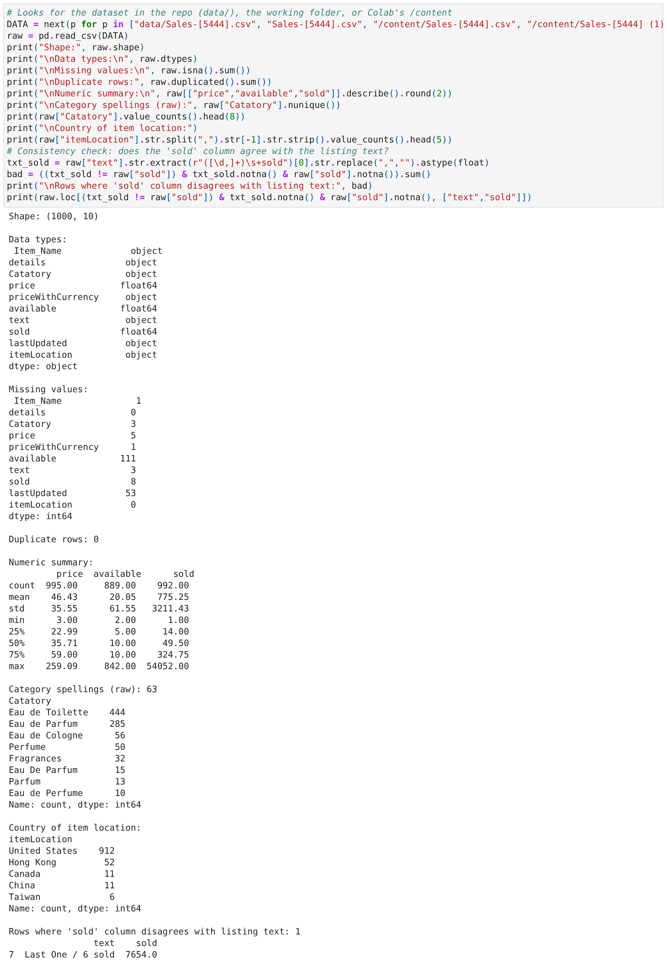
Figure A1: Importing the CSV file and inspecting data quality
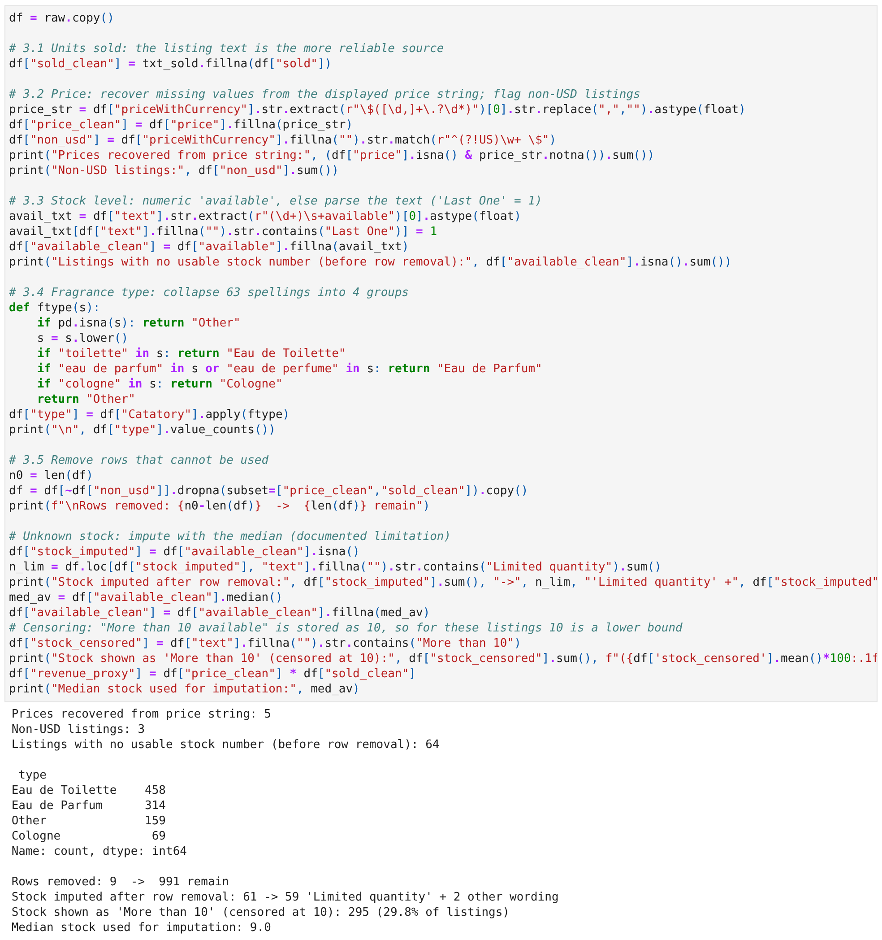
Figure A2: Cleaning the data
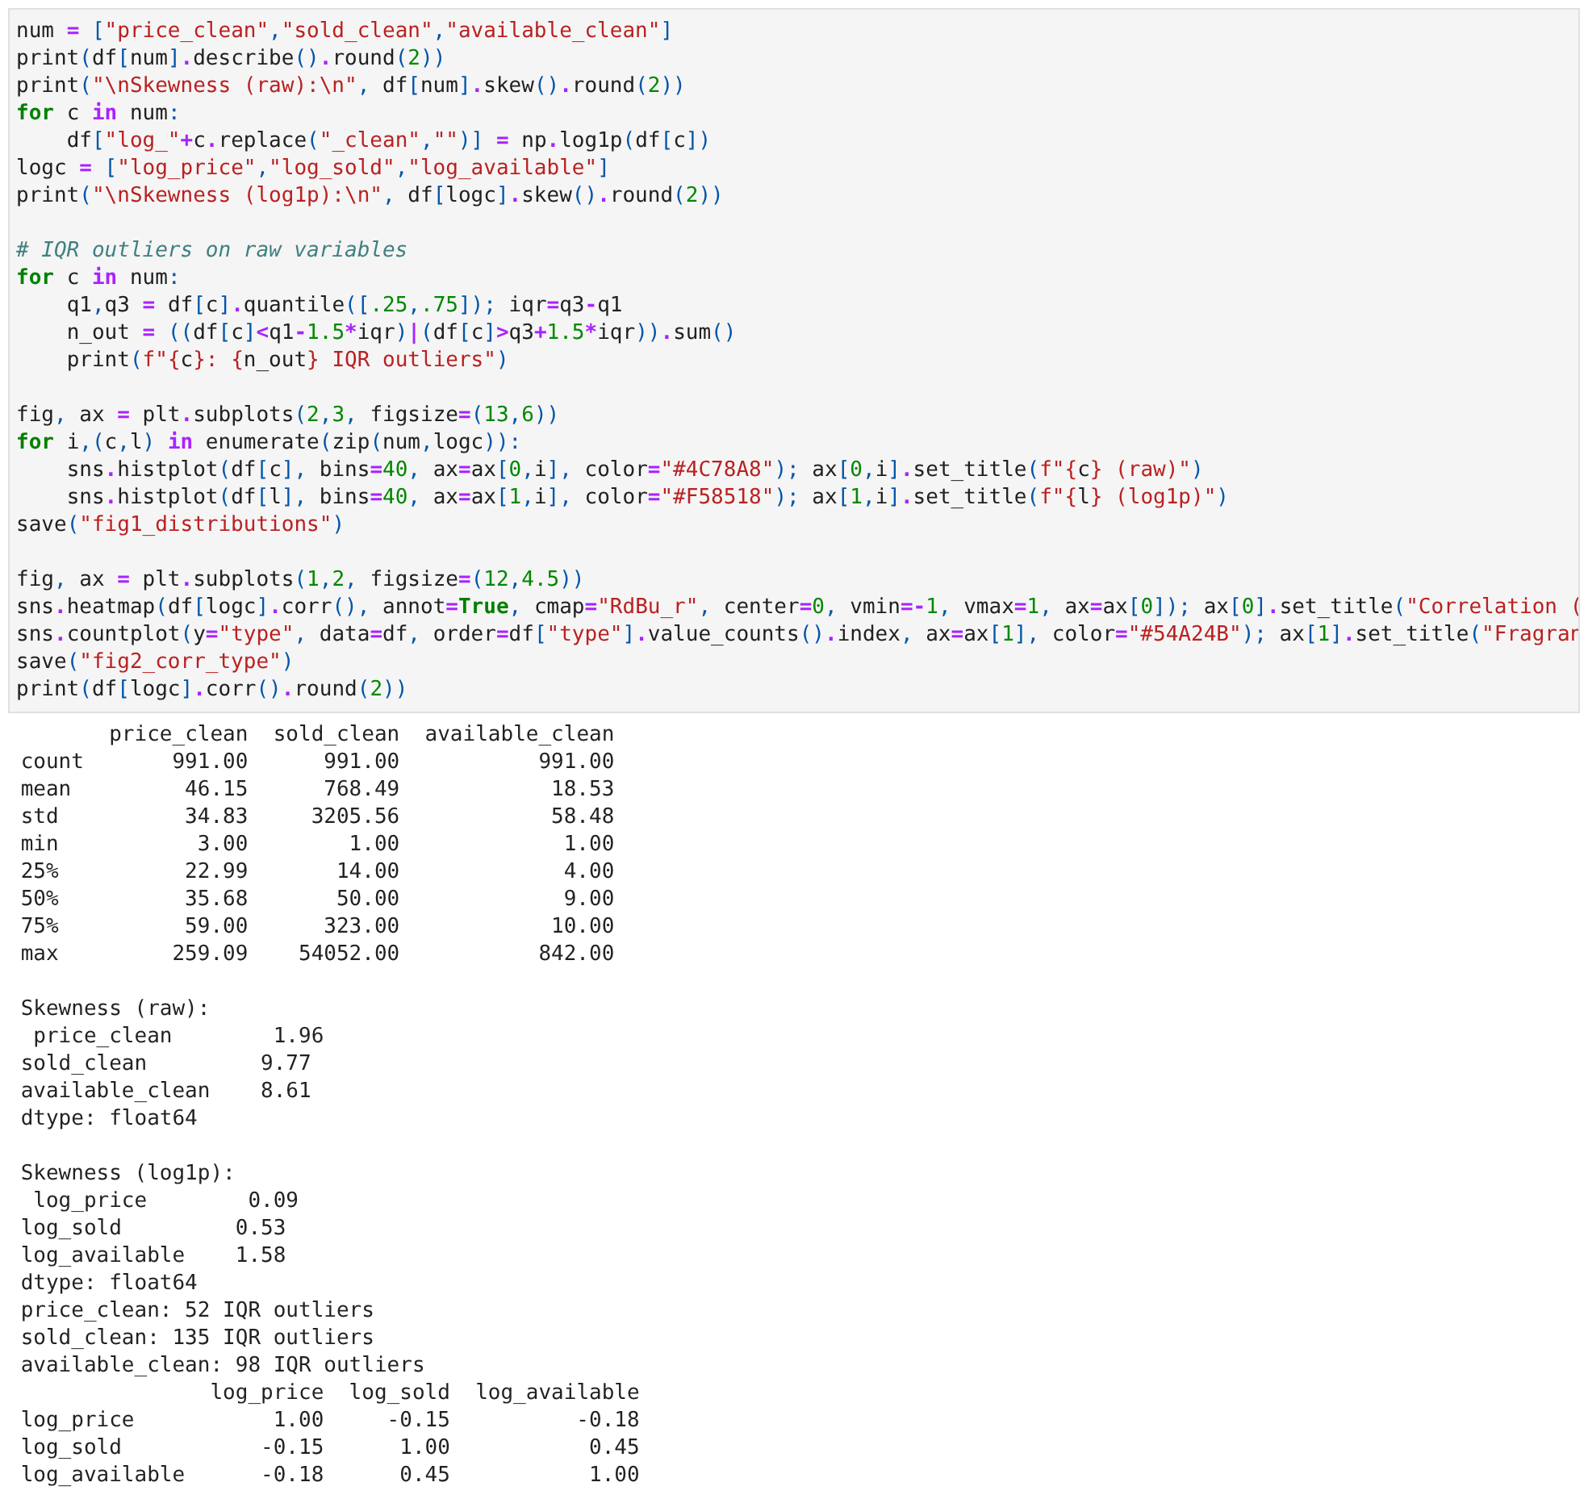
Figure A3: Descriptive statistics, skewness, outliers and correlation
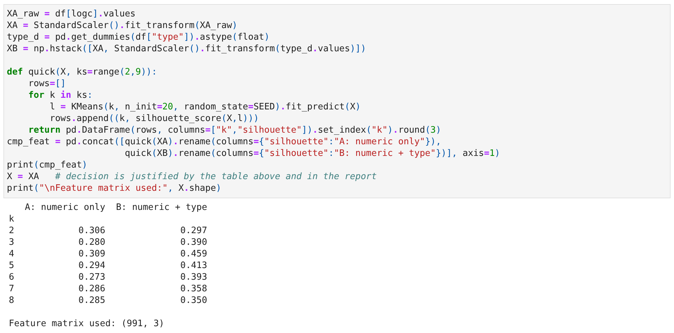
Figure A4: Comparing feature sets A and B
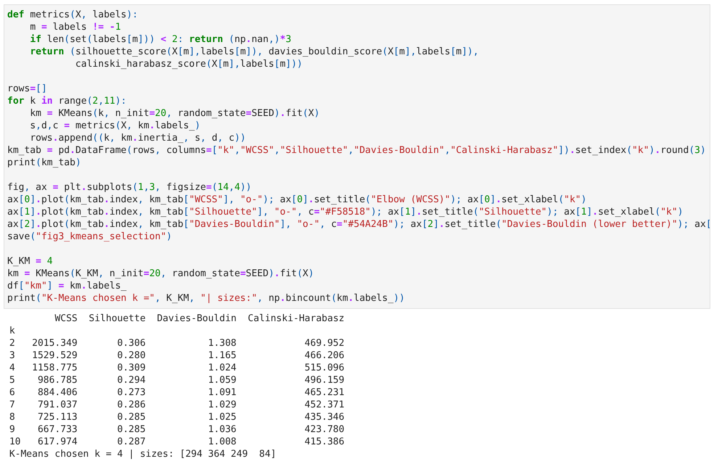
Figure A5: K-Means evaluation for k = 2 to 10
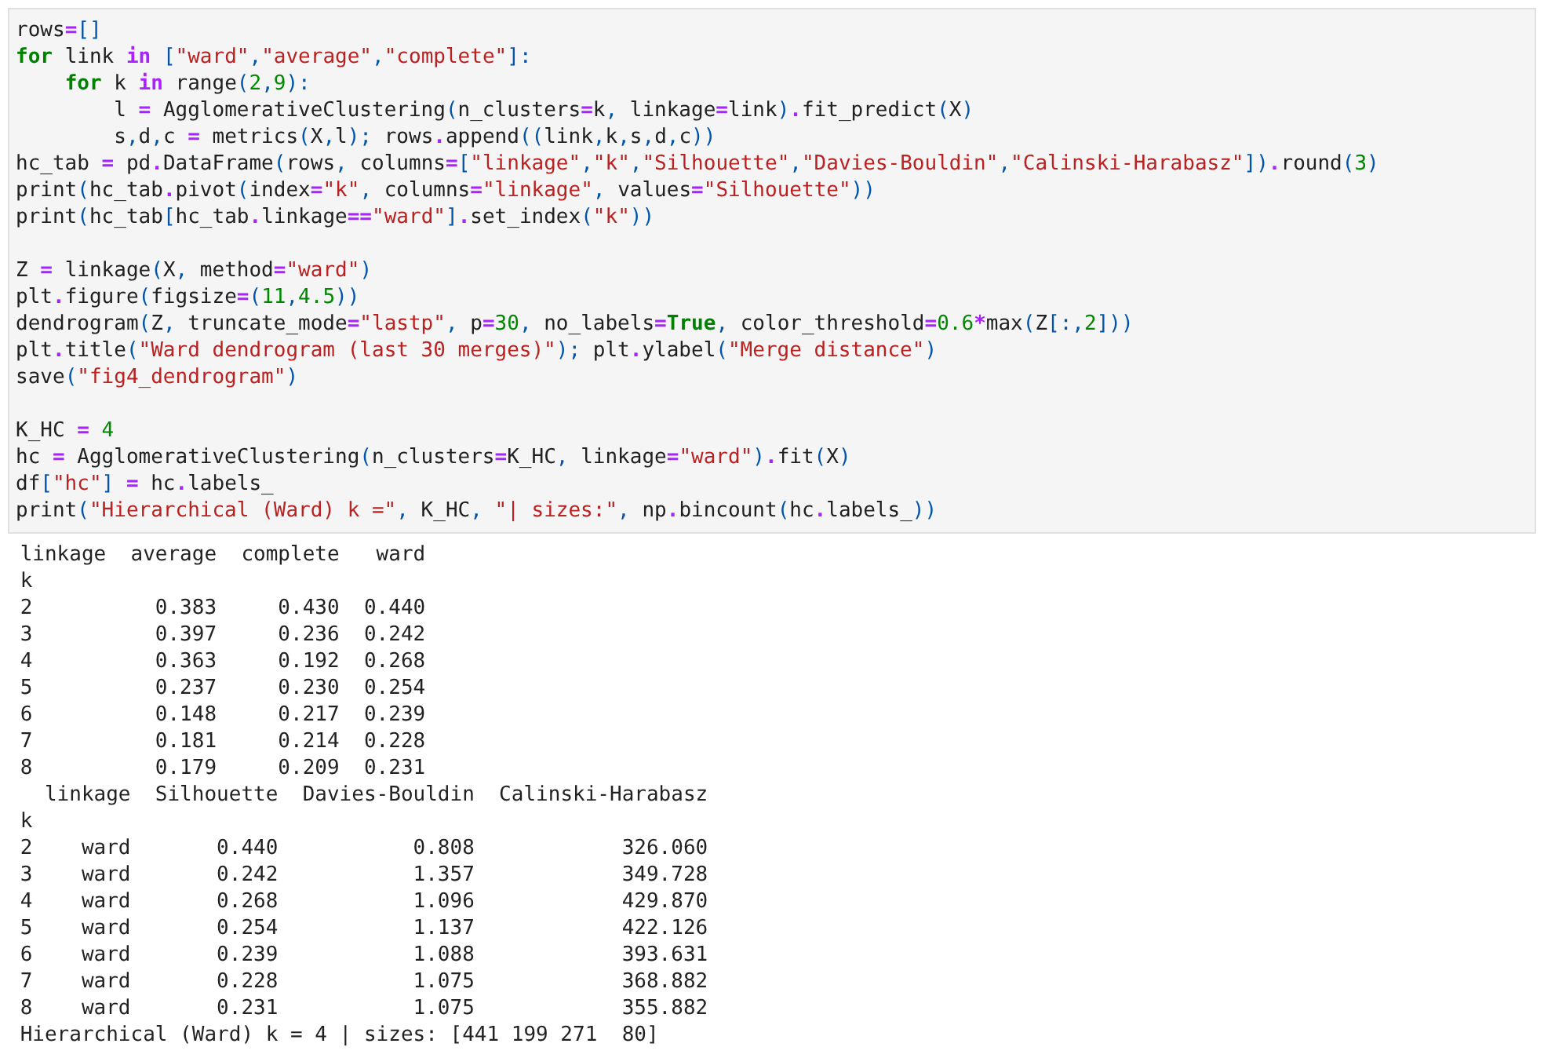
Figure A6: Hierarchical clustering evaluation
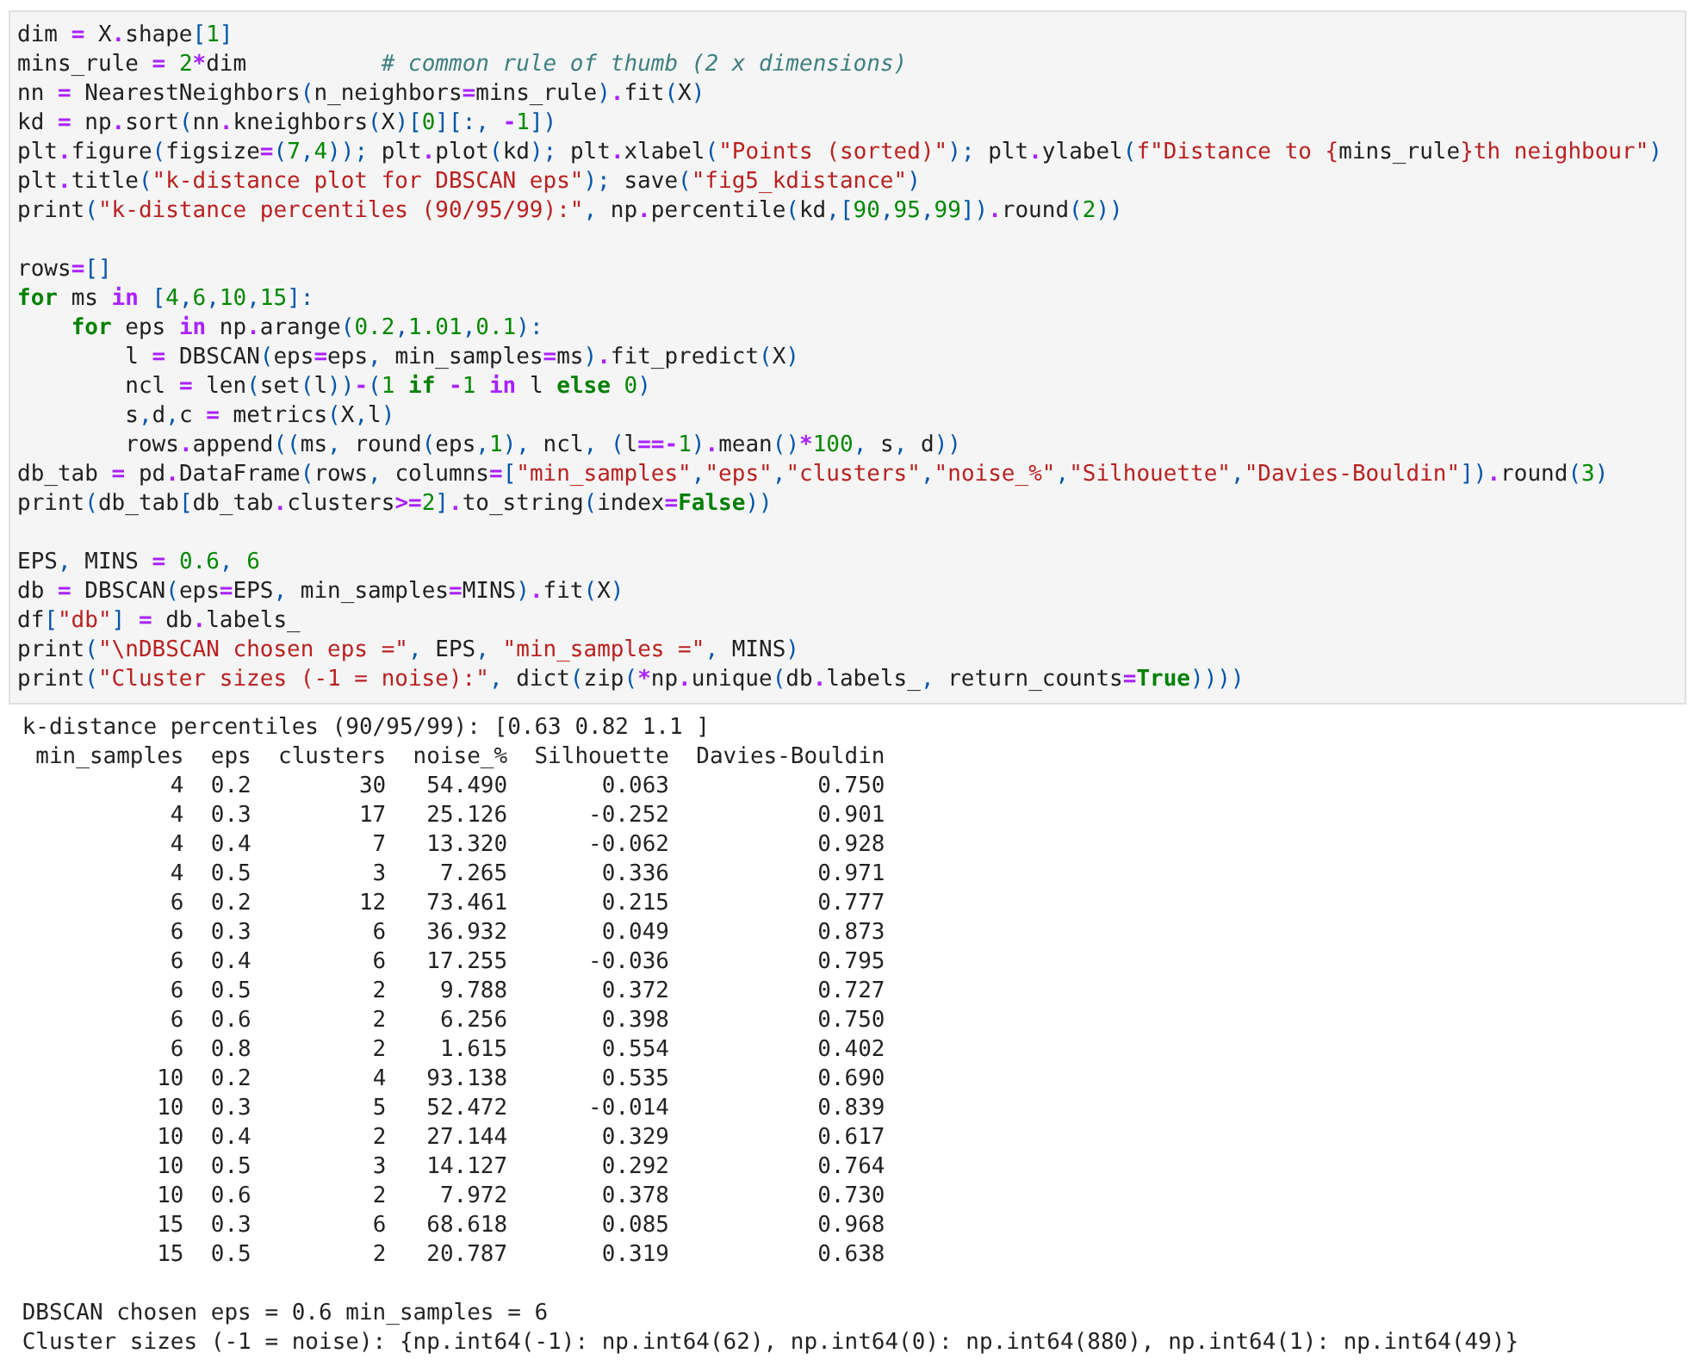
Figure A7: DBSCAN parameter search
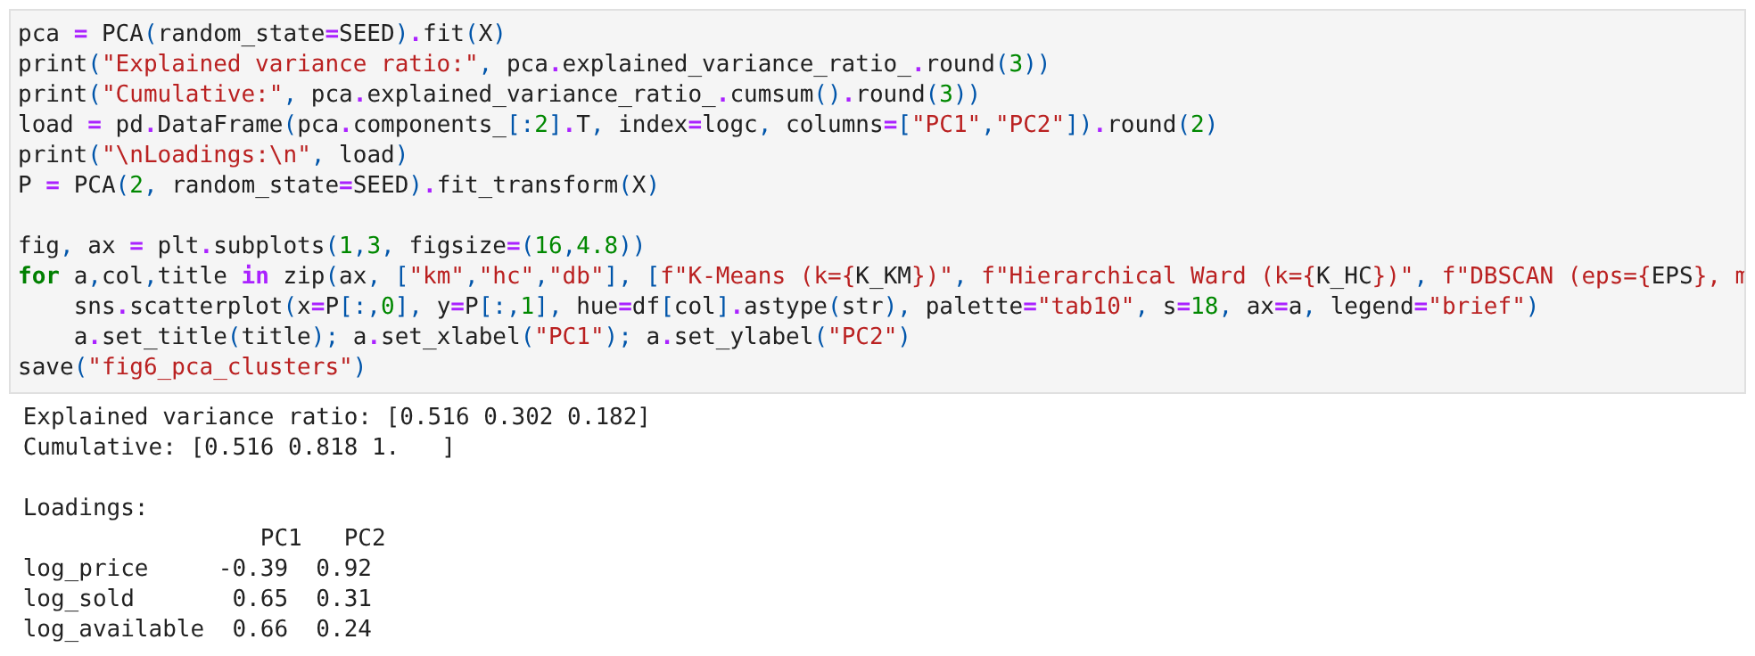
Figure A8: PCA explained variance and loadings
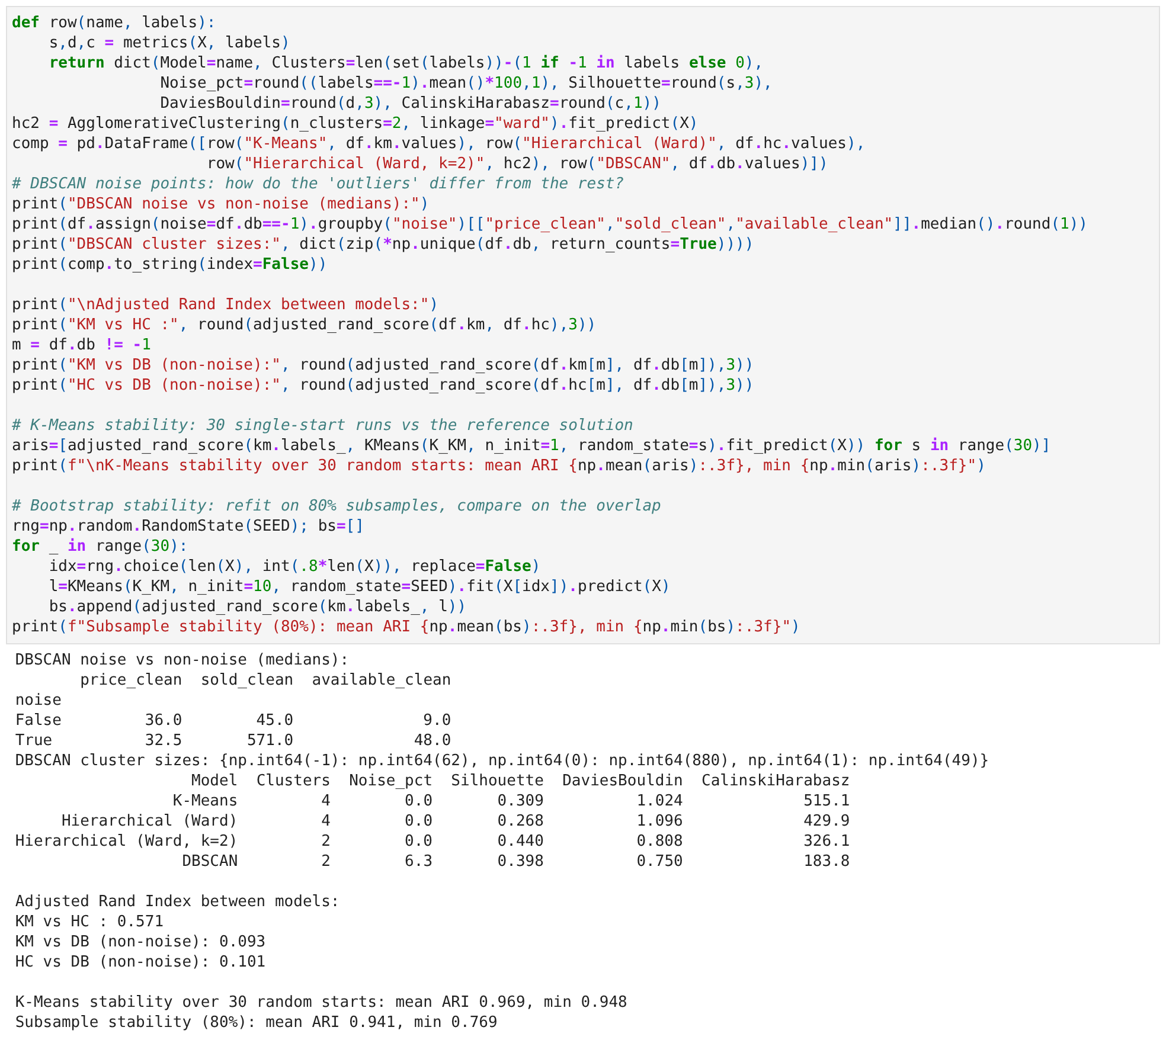
Figure A9: Model comparison and stability checks
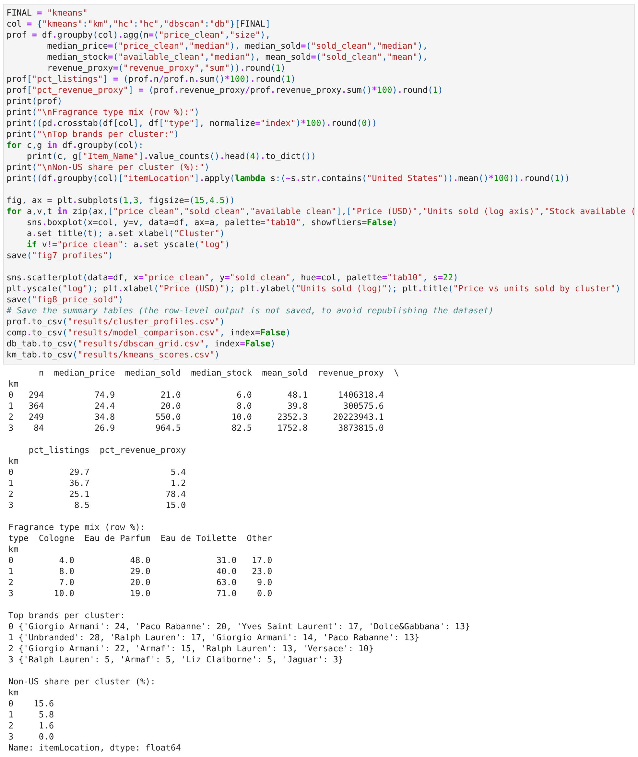
Figure A10: Profiles of the K-Means clusters
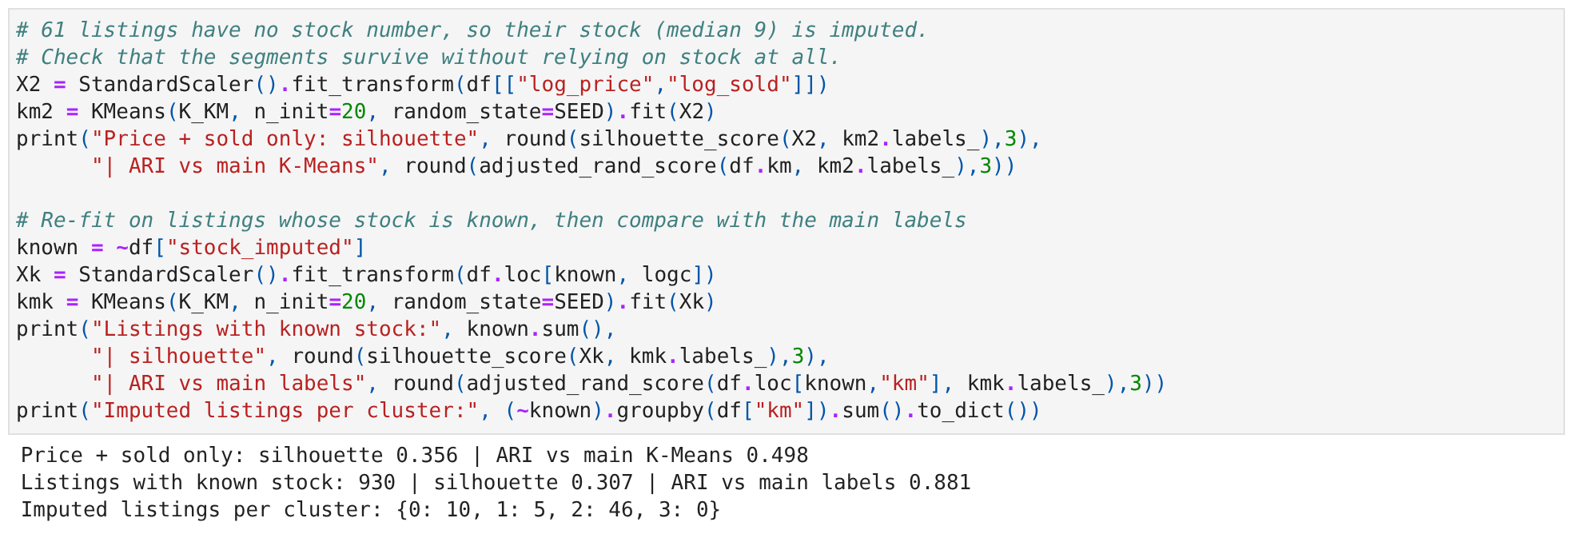
Figure A11: Robustness check on the imputed stock values
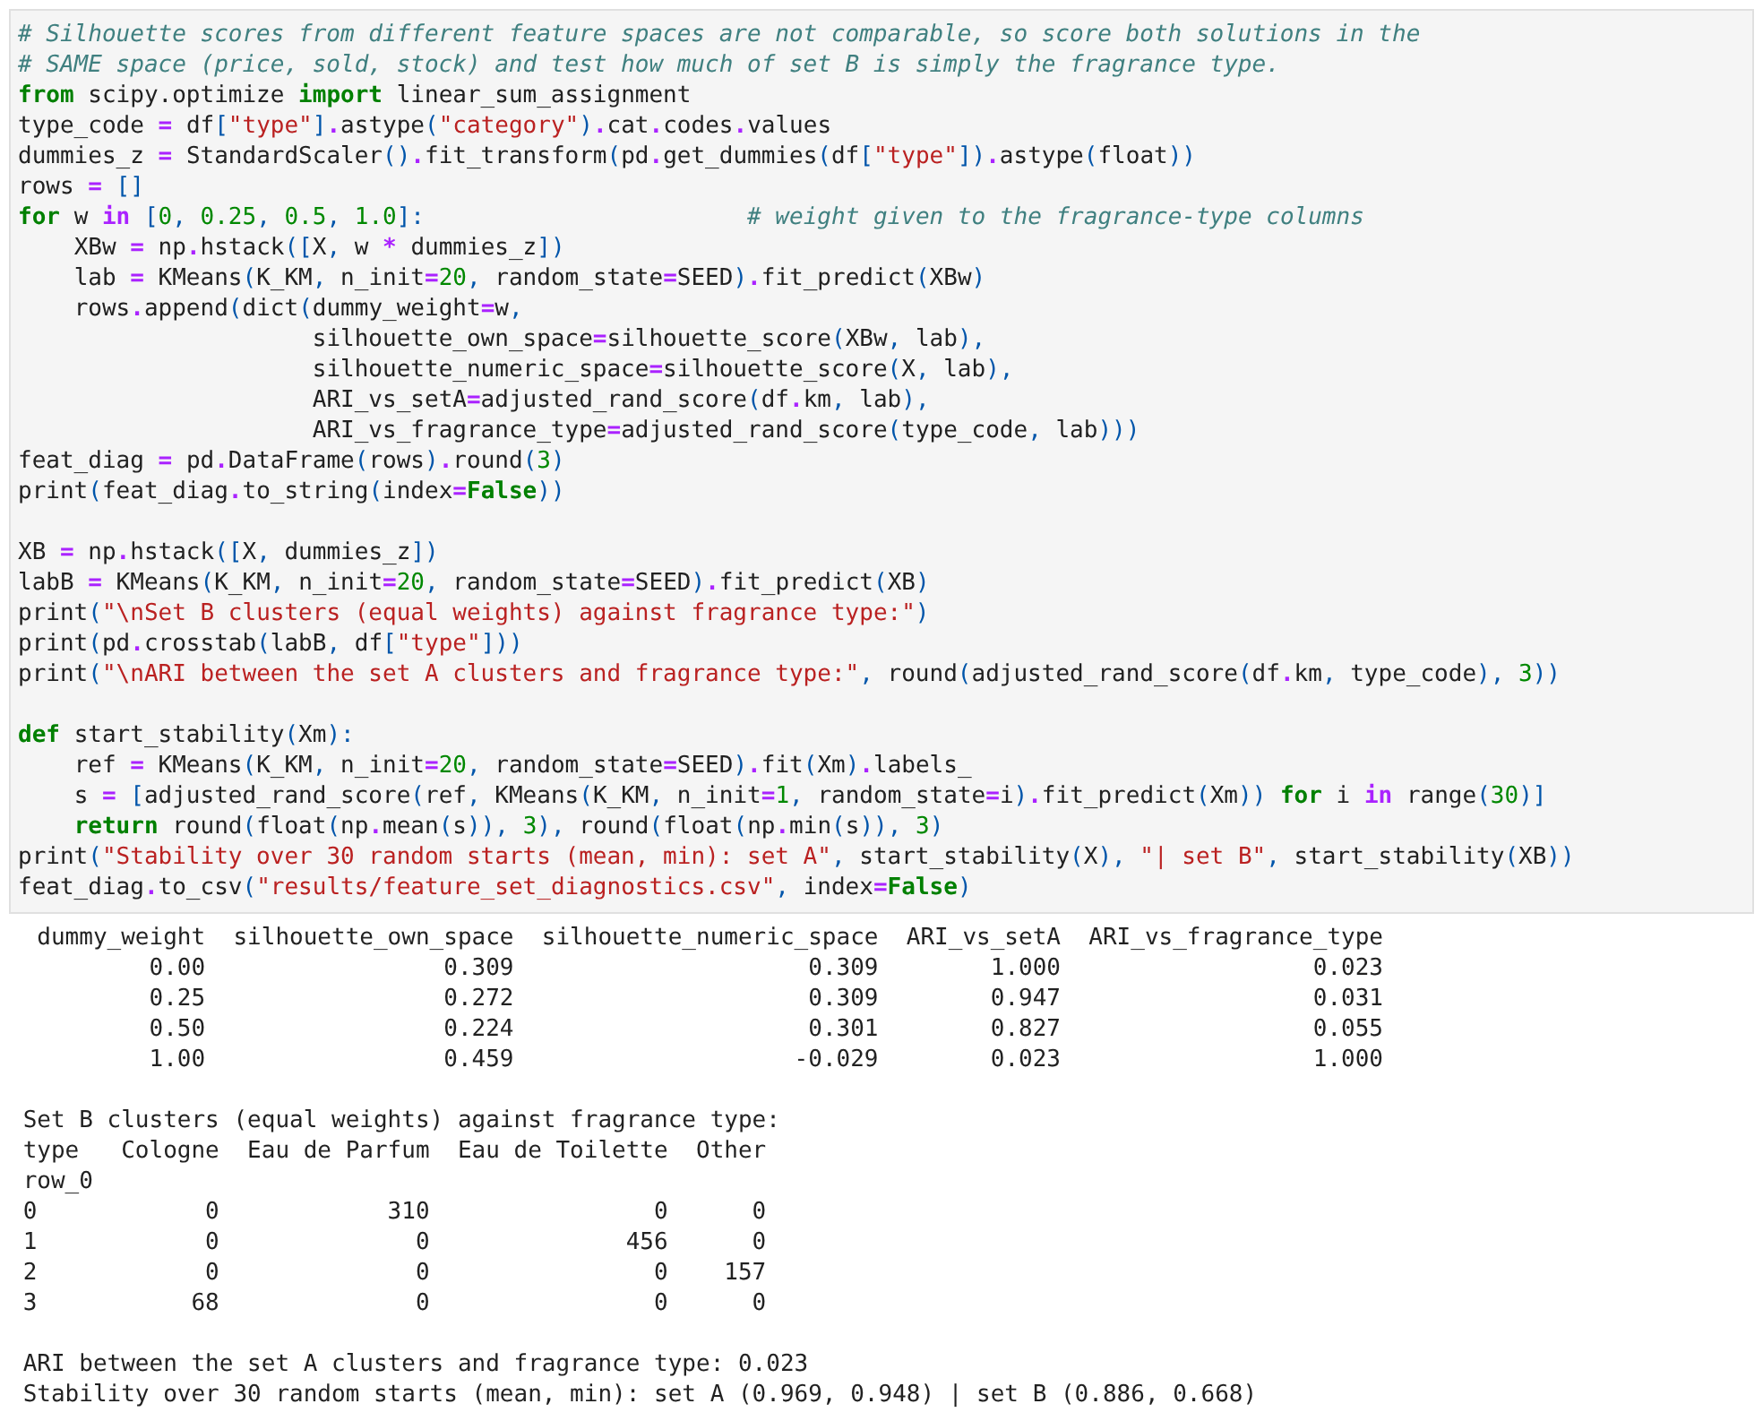
Figure A12: Diagnostics for feature sets A and B
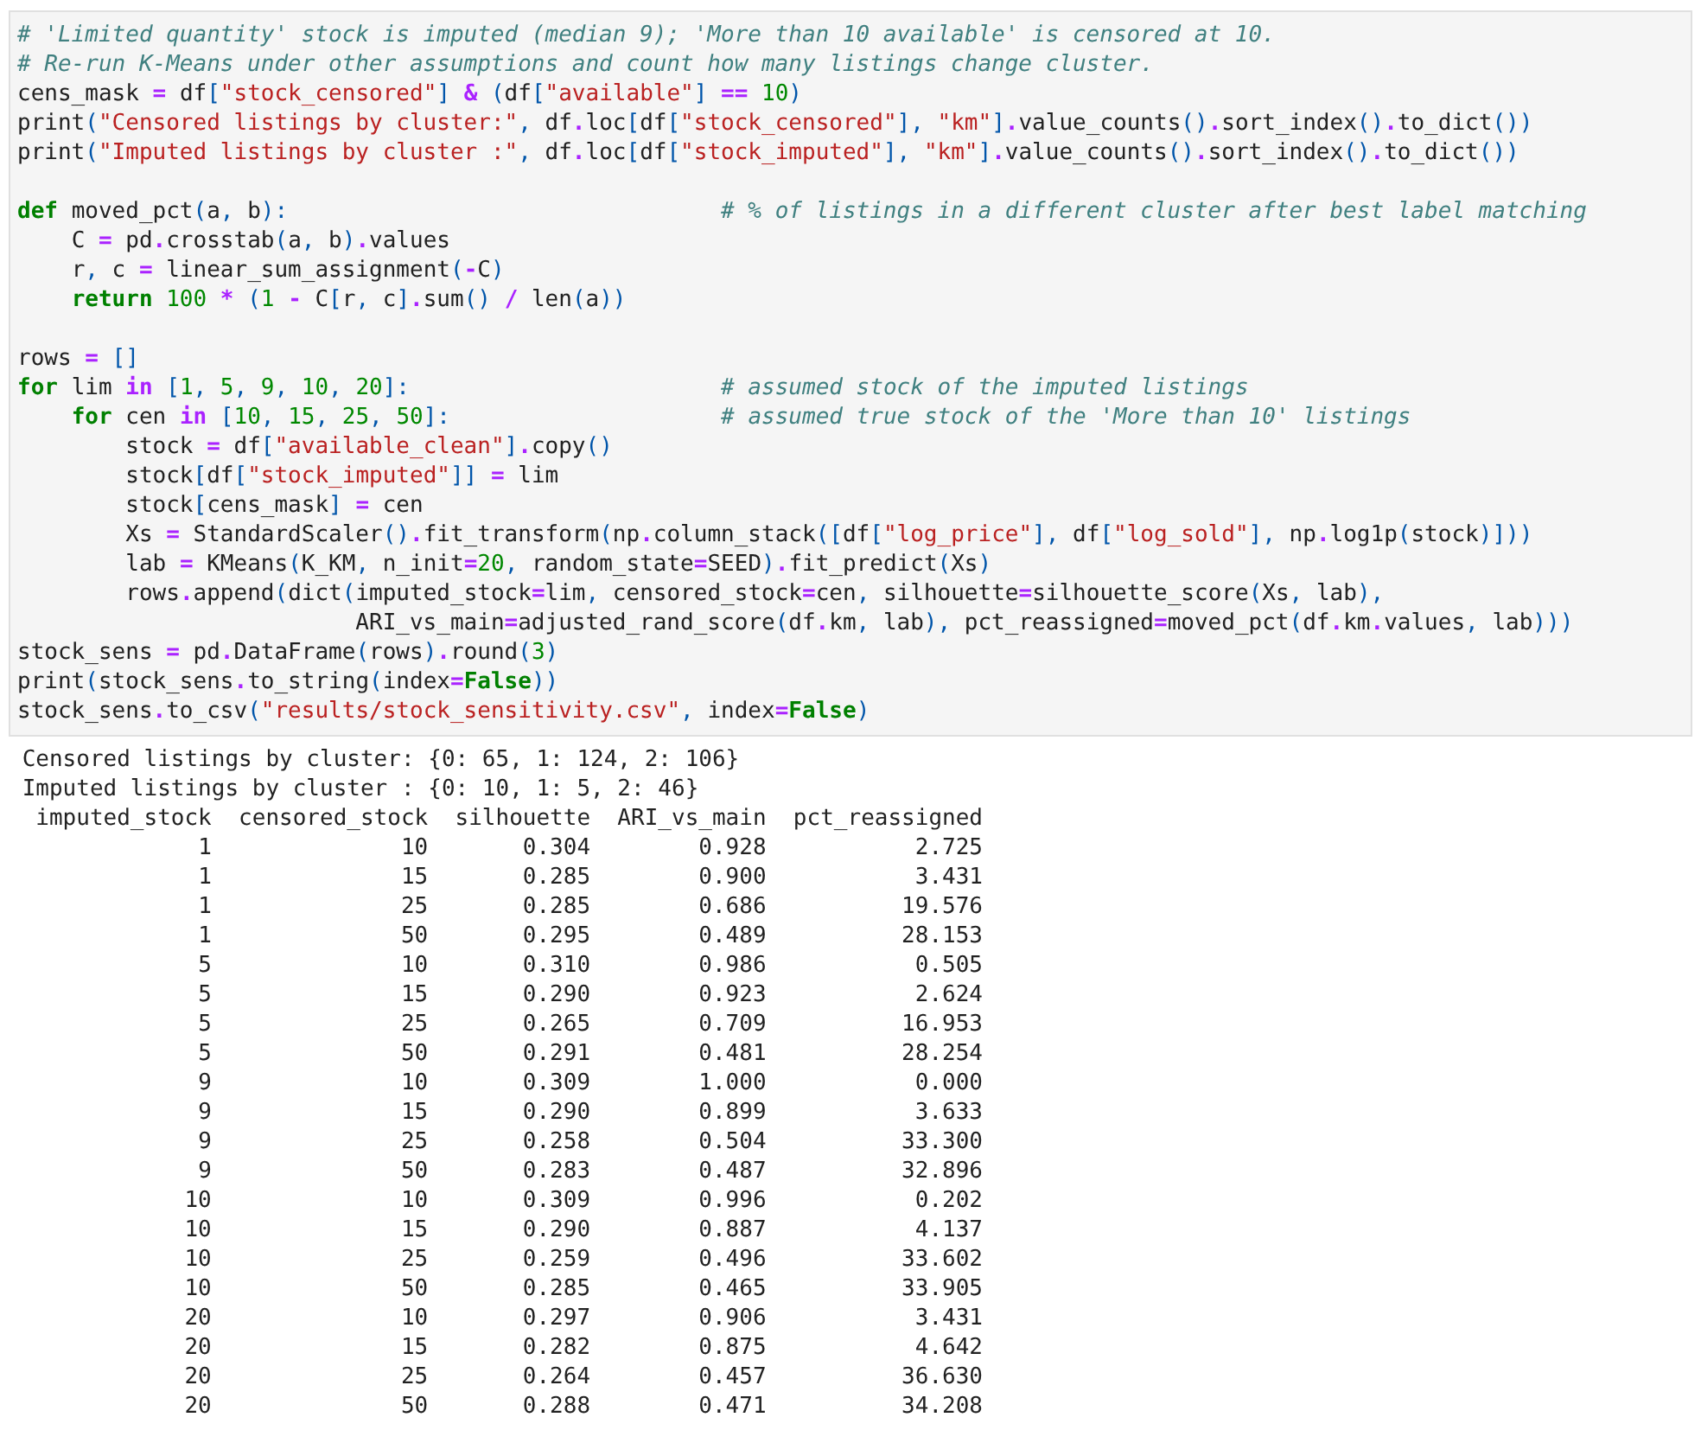
Figure A13: Sensitivity of the clusters to imputed and censored stock
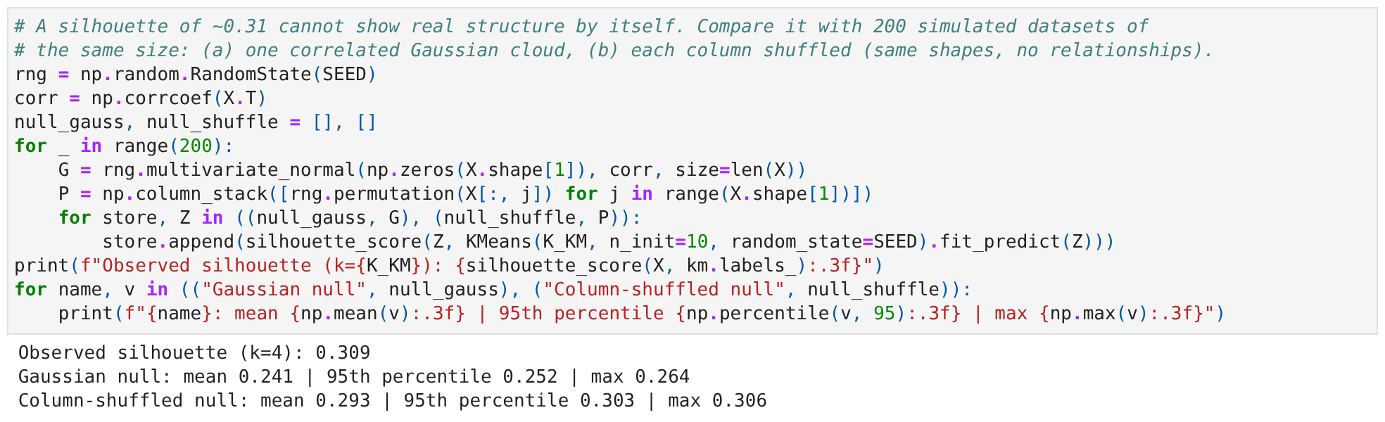
Figure A14: Observed silhouette compared with null data
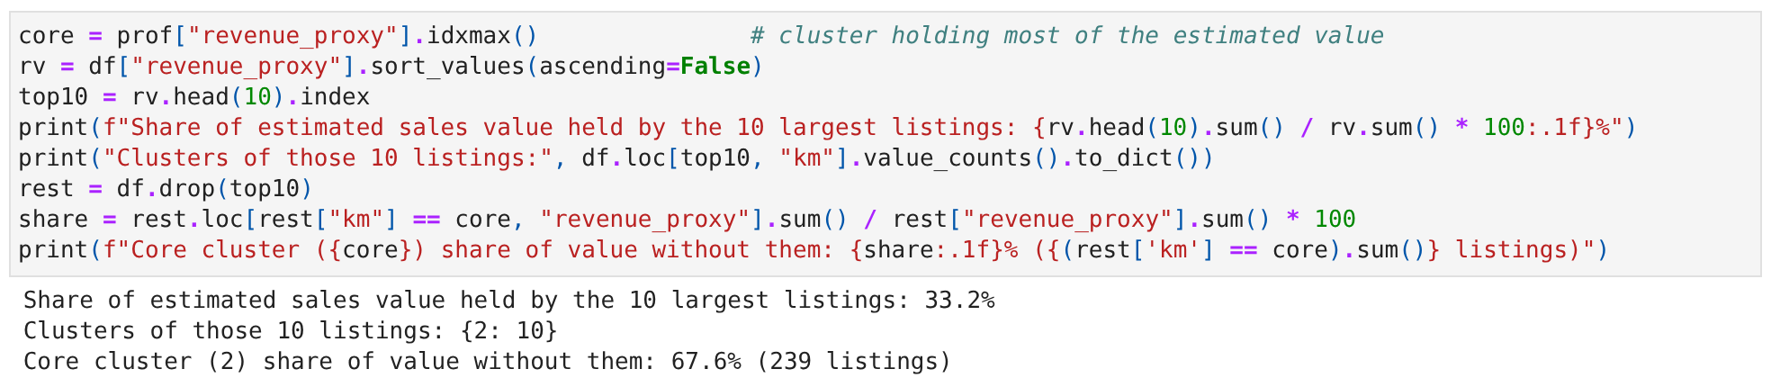
Figure A15: Concentration of estimated sales value

Appendix B: Python code (COM7022_clustering_executed.ipynb)
# 1. Setup
import re, warnings, os
import numpy as np, pandas as pd
import matplotlib.pyplot as plt, seaborn as sns
from sklearn.preprocessing import StandardScaler
from sklearn.cluster import KMeans, AgglomerativeClustering, DBSCAN
from sklearn.decomposition import PCA
from sklearn.neighbors import NearestNeighbors
from sklearn.metrics import (silhouette_score, davies_bouldin_score,
calinski_harabasz_score, adjusted_rand_score)
from scipy.cluster.hierarchy import linkage, dendrogram
warnings.filterwarnings("ignore")
SEED = 42
np.random.seed(SEED)
sns.set_theme(style="whitegrid", context="notebook")
os.makedirs("figures", exist_ok=True); os.makedirs("results", exist_ok=True)
def save(name):
plt.tight_layout(); plt.savefig(f"figures/{name}.png", dpi=160); plt.show()
2. Data understanding
# Looks for the dataset in the repo (data/), the working folder, or Colab's /content
DATA = next(p for p in ["data/Sales-[5444].csv", "Sales-[5444].csv", "/content/Sales-[5444].csv", "/content/Sales-[5444] (1).csv"] if os.path.exists(p))
raw = pd.read_csv(DATA)
print("Shape:", raw.shape)
print("\nData types:\n", raw.dtypes)
print("\nMissing values:\n", raw.isna().sum())
print("\nDuplicate rows:", raw.duplicated().sum())
print("\nNumeric summary:\n", raw[["price","available","sold"]].describe().round(2))
print("\nCategory spellings (raw):", raw["Catatory"].nunique())
print(raw["Catatory"].value_counts().head(8))
print("\nCountry of item location:")
print(raw["itemLocation"].str.split(",").str[-1].str.strip().value_counts().head(5))
# Consistency check: does the 'sold' column agree with the listing text?
txt_sold = raw["text"].str.extract(r"([\d,]+)\s+sold")[0].str.replace(",","").astype(float)
bad = ((txt_sold != raw["sold"]) & txt_sold.notna() & raw["sold"].notna()).sum()
print("\nRows where 'sold' column disagrees with listing text:", bad)
print(raw.loc[(txt_sold != raw["sold"]) & txt_sold.notna() & raw["sold"].notna(), ["text","sold"]])
3. Cleaning
df = raw.copy()
# 3.1 Units sold: the listing text is the more reliable source
df["sold_clean"] = txt_sold.fillna(df["sold"])
# 3.2 Price: recover missing values from the displayed price string; flag non-USD listings
price_str = df["priceWithCurrency"].str.extract(r"\$([\d,]+\.?\d*)")[0].str.replace(",","").astype(float)
df["price_clean"] = df["price"].fillna(price_str)
df["non_usd"] = df["priceWithCurrency"].fillna("").str.match(r"^(?!US)\w+ \$")
print("Prices recovered from price string:", (df["price"].isna() & price_str.notna()).sum())
print("Non-USD listings:", df["non_usd"].sum())
# 3.3 Stock level: numeric 'available', else parse the text ('Last One' = 1)
avail_txt = df["text"].str.extract(r"(\d+)\s+available")[0].astype(float)
avail_txt[df["text"].fillna("").str.contains("Last One")] = 1
df["available_clean"] = df["available"].fillna(avail_txt)
print("Listings with no usable stock number (before row removal):", df["available_clean"].isna().sum())
# 3.4 Fragrance type: collapse 63 spellings into 4 groups
def ftype(s):
if pd.isna(s): return "Other"
s = s.lower()
if "toilette" in s: return "Eau de Toilette"
if "eau de parfum" in s or "eau de perfume" in s: return "Eau de Parfum"
if "cologne" in s: return "Cologne"
return "Other"
df["type"] = df["Catatory"].apply(ftype)
print("\n", df["type"].value_counts())
# 3.5 Remove rows that cannot be used
n0 = len(df)
df = df[~df["non_usd"]].dropna(subset=["price_clean","sold_clean"]).copy()
print(f"\nRows removed: {n0-len(df)} -> {len(df)} remain")
# Unknown stock: impute with the median (documented limitation)
df["stock_imputed"] = df["available_clean"].isna()
n_lim = df.loc[df["stock_imputed"], "text"].fillna("").str.contains("Limited quantity").sum()
print("Stock imputed after row removal:", df["stock_imputed"].sum(), "->", n_lim, "'Limited quantity' +", df["stock_imputed"].sum() - n_lim, "other wording")
med_av = df["available_clean"].median()
df["available_clean"] = df["available_clean"].fillna(med_av)
# Censoring: "More than 10 available" is stored as 10, so for these listings 10 is a lower bound
df["stock_censored"] = df["text"].fillna("").str.contains("More than 10")
print("Stock shown as 'More than 10' (censored at 10):", df["stock_censored"].sum(), f"({df['stock_censored'].mean()*100:.1f}% of listings)")
df["revenue_proxy"] = df["price_clean"] * df["sold_clean"]
print("Median stock used for imputation:", med_av)
4. Exploration of the cleaned data
num = ["price_clean","sold_clean","available_clean"]
print(df[num].describe().round(2))
print("\nSkewness (raw):\n", df[num].skew().round(2))
for c in num:
df["log_"+c.replace("_clean","")] = np.log1p(df[c])
logc = ["log_price","log_sold","log_available"]
print("\nSkewness (log1p):\n", df[logc].skew().round(2))
# IQR outliers on raw variables
for c in num:
q1,q3 = df[c].quantile([.25,.75]); iqr=q3-q1
n_out = ((df[c]<q1-1.5*iqr)|(df[c]>q3+1.5*iqr)).sum()
print(f"{c}: {n_out} IQR outliers")
fig, ax = plt.subplots(2,3, figsize=(13,6))
for i,(c,l) in enumerate(zip(num,logc)):
sns.histplot(df[c], bins=40, ax=ax[0,i], color="#4C78A8"); ax[0,i].set_title(f"{c} (raw)")
sns.histplot(df[l], bins=40, ax=ax[1,i], color="#F58518"); ax[1,i].set_title(f"{l} (log1p)")
save("fig1_distributions")
fig, ax = plt.subplots(1,2, figsize=(12,4.5))
sns.heatmap(df[logc].corr(), annot=True, cmap="RdBu_r", center=0, vmin=-1, vmax=1, ax=ax[0]); ax[0].set_title("Correlation (log features)")
sns.countplot(y="type", data=df, order=df["type"].value_counts().index, ax=ax[1], color="#54A24B"); ax[1].set_title("Fragrance type")
save("fig2_corr_type")
print(df[logc].corr().round(2))
5. Feature selection and scaling
XA_raw = df[logc].values
XA = StandardScaler().fit_transform(XA_raw)
type_d = pd.get_dummies(df["type"]).astype(float)
XB = np.hstack([XA, StandardScaler().fit_transform(type_d.values)])
def quick(X, ks=range(2,9)):
rows=[]
for k in ks:
l = KMeans(k, n_init=20, random_state=SEED).fit_predict(X)
rows.append((k, silhouette_score(X,l)))
return pd.DataFrame(rows, columns=["k","silhouette"]).set_index("k").round(3)
cmp_feat = pd.concat([quick(XA).rename(columns={"silhouette":"A: numeric only"}),
quick(XB).rename(columns={"silhouette":"B: numeric + type"})], axis=1)
print(cmp_feat)
X = XA # decision is justified by the table above and in the report
print("\nFeature matrix used:", X.shape)
6. K-Means
def metrics(X, labels):
m = labels != -1
if len(set(labels[m])) < 2: return (np.nan,)*3
return (silhouette_score(X[m],labels[m]), davies_bouldin_score(X[m],labels[m]),
calinski_harabasz_score(X[m],labels[m]))
rows=[]
for k in range(2,11):
km = KMeans(k, n_init=20, random_state=SEED).fit(X)
s,d,c = metrics(X, km.labels_)
rows.append((k, km.inertia_, s, d, c))
km_tab = pd.DataFrame(rows, columns=["k","WCSS","Silhouette","Davies-Bouldin","Calinski-Harabasz"]).set_index("k").round(3)
print(km_tab)
fig, ax = plt.subplots(1,3, figsize=(14,4))
ax[0].plot(km_tab.index, km_tab["WCSS"], "o-"); ax[0].set_title("Elbow (WCSS)"); ax[0].set_xlabel("k")
ax[1].plot(km_tab.index, km_tab["Silhouette"], "o-", c="#F58518"); ax[1].set_title("Silhouette"); ax[1].set_xlabel("k")
ax[2].plot(km_tab.index, km_tab["Davies-Bouldin"], "o-", c="#54A24B"); ax[2].set_title("Davies-Bouldin (lower better)"); ax[2].set_xlabel("k")
save("fig3_kmeans_selection")
K_KM = 4
km = KMeans(K_KM, n_init=20, random_state=SEED).fit(X)
df["km"] = km.labels_
print("K-Means chosen k =", K_KM, "| sizes:", np.bincount(km.labels_))
7. Hierarchical clustering
rows=[]
for link in ["ward","average","complete"]:
for k in range(2,9):
l = AgglomerativeClustering(n_clusters=k, linkage=link).fit_predict(X)
s,d,c = metrics(X,l); rows.append((link,k,s,d,c))
hc_tab = pd.DataFrame(rows, columns=["linkage","k","Silhouette","Davies-Bouldin","Calinski-Harabasz"]).round(3)
print(hc_tab.pivot(index="k", columns="linkage", values="Silhouette"))
print(hc_tab[hc_tab.linkage=="ward"].set_index("k"))
Z = linkage(X, method="ward")
plt.figure(figsize=(11,4.5))
dendrogram(Z, truncate_mode="lastp", p=30, no_labels=True, color_threshold=0.6*max(Z[:,2]))
plt.title("Ward dendrogram (last 30 merges)"); plt.ylabel("Merge distance")
save("fig4_dendrogram")
K_HC = 4
hc = AgglomerativeClustering(n_clusters=K_HC, linkage="ward").fit(X)
df["hc"] = hc.labels_
print("Hierarchical (Ward) k =", K_HC, "| sizes:", np.bincount(hc.labels_))
8. DBSCAN
dim = X.shape[1]
mins_rule = 2*dim # common rule of thumb (2 x dimensions)
nn = NearestNeighbors(n_neighbors=mins_rule).fit(X)
kd = np.sort(nn.kneighbors(X)[0][:, -1])
plt.figure(figsize=(7,4)); plt.plot(kd); plt.xlabel("Points (sorted)"); plt.ylabel(f"Distance to {mins_rule}th neighbour")
plt.title("k-distance plot for DBSCAN eps"); save("fig5_kdistance")
print("k-distance percentiles (90/95/99):", np.percentile(kd,[90,95,99]).round(2))
rows=[]
for ms in [4,6,10,15]:
for eps in np.arange(0.2,1.01,0.1):
l = DBSCAN(eps=eps, min_samples=ms).fit_predict(X)
ncl = len(set(l))-(1 if -1 in l else 0)
s,d,c = metrics(X,l)
rows.append((ms, round(eps,1), ncl, (l==-1).mean()*100, s, d))
db_tab = pd.DataFrame(rows, columns=["min_samples","eps","clusters","noise_%","Silhouette","Davies-Bouldin"]).round(3)
print(db_tab[db_tab.clusters>=2].to_string(index=False))
EPS, MINS = 0.6, 6
db = DBSCAN(eps=EPS, min_samples=MINS).fit(X)
df["db"] = db.labels_
print("\nDBSCAN chosen eps =", EPS, "min_samples =", MINS)
print("Cluster sizes (-1 = noise):", dict(zip(*np.unique(db.labels_, return_counts=True))))
9. PCA
pca = PCA(random_state=SEED).fit(X)
print("Explained variance ratio:", pca.explained_variance_ratio_.round(3))
print("Cumulative:", pca.explained_variance_ratio_.cumsum().round(3))
load = pd.DataFrame(pca.components_[:2].T, index=logc, columns=["PC1","PC2"]).round(2)
print("\nLoadings:\n", load)
P = PCA(2, random_state=SEED).fit_transform(X)
fig, ax = plt.subplots(1,3, figsize=(16,4.8))
for a,col,title in zip(ax, ["km","hc","db"], [f"K-Means (k={K_KM})", f"Hierarchical Ward (k={K_HC})", f"DBSCAN (eps={EPS}, min_samples={MINS})"]):
sns.scatterplot(x=P[:,0], y=P[:,1], hue=df[col].astype(str), palette="tab10", s=18, ax=a, legend="brief")
a.set_title(title); a.set_xlabel("PC1"); a.set_ylabel("PC2")
save("fig6_pca_clusters")
10. Model comparison and stability
def row(name, labels):
s,d,c = metrics(X, labels)
return dict(Model=name, Clusters=len(set(labels))-(1 if -1 in labels else 0),
Noise_pct=round((labels==-1).mean()*100,1), Silhouette=round(s,3),
DaviesBouldin=round(d,3), CalinskiHarabasz=round(c,1))
hc2 = AgglomerativeClustering(n_clusters=2, linkage="ward").fit_predict(X)
comp = pd.DataFrame([row("K-Means", df.km.values), row("Hierarchical (Ward)", df.hc.values),
row("Hierarchical (Ward, k=2)", hc2), row("DBSCAN", df.db.values)])
# DBSCAN noise points: how do the 'outliers' differ from the rest?
print("DBSCAN noise vs non-noise (medians):")
print(df.assign(noise=df.db==-1).groupby("noise")[["price_clean","sold_clean","available_clean"]].median().round(1))
print("DBSCAN cluster sizes:", dict(zip(*np.unique(df.db, return_counts=True))))
print(comp.to_string(index=False))
print("\nAdjusted Rand Index between models:")
print("KM vs HC :", round(adjusted_rand_score(df.km, df.hc),3))
m = df.db != -1
print("KM vs DB (non-noise):", round(adjusted_rand_score(df.km[m], df.db[m]),3))
print("HC vs DB (non-noise):", round(adjusted_rand_score(df.hc[m], df.db[m]),3))
# K-Means stability: 30 single-start runs vs the reference solution
aris=[adjusted_rand_score(km.labels_, KMeans(K_KM, n_init=1, random_state=s).fit_predict(X)) for s in range(30)]
print(f"\nK-Means stability over 30 random starts: mean ARI {np.mean(aris):.3f}, min {np.min(aris):.3f}")
# Bootstrap stability: refit on 80% subsamples, compare on the overlap
rng=np.random.RandomState(SEED); bs=[]
for _ in range(30):
idx=rng.choice(len(X), int(.8*len(X)), replace=False)
l=KMeans(K_KM, n_init=10, random_state=SEED).fit(X[idx]).predict(X)
bs.append(adjusted_rand_score(km.labels_, l))
print(f"Subsample stability (80%): mean ARI {np.mean(bs):.3f}, min {np.min(bs):.3f}")
11. Cluster profiles for the chosen model
FINAL = "kmeans"
col = {"kmeans":"km","hc":"hc","dbscan":"db"}[FINAL]
prof = df.groupby(col).agg(n=("price_clean","size"),
median_price=("price_clean","median"), median_sold=("sold_clean","median"),
median_stock=("available_clean","median"), mean_sold=("sold_clean","mean"),
revenue_proxy=("revenue_proxy","sum")).round(1)
prof["pct_listings"] = (prof.n/prof.n.sum()*100).round(1)
prof["pct_revenue_proxy"] = (prof.revenue_proxy/prof.revenue_proxy.sum()*100).round(1)
print(prof)
print("\nFragrance type mix (row %):")
print((pd.crosstab(df[col], df["type"], normalize="index")*100).round(0))
print("\nTop brands per cluster:")
for c,g in df.groupby(col):
print(c, g["Item_Name"].value_counts().head(4).to_dict())
print("\nNon-US share per cluster (%):")
print((df.groupby(col)["itemLocation"].apply(lambda s:(~s.str.contains("United States")).mean()*100)).round(1))
fig, ax = plt.subplots(1,3, figsize=(15,4.5))
for a,v,t in zip(ax,["price_clean","sold_clean","available_clean"],["Price (USD)","Units sold (log axis)","Stock available (log axis)"]):
sns.boxplot(x=col, y=v, data=df, ax=a, palette="tab10", showfliers=False)
a.set_title(t); a.set_xlabel("Cluster")
if v!="price_clean": a.set_yscale("log")
save("fig7_profiles")
sns.scatterplot(data=df, x="price_clean", y="sold_clean", hue=col, palette="tab10", s=22)
plt.yscale("log"); plt.xlabel("Price (USD)"); plt.ylabel("Units sold (log)"); plt.title("Price vs units sold by cluster")
save("fig8_price_sold")
# Save the summary tables (the row-level output is not saved, to avoid republishing the dataset)
prof.to_csv("results/cluster_profiles.csv")
comp.to_csv("results/model_comparison.csv", index=False)
db_tab.to_csv("results/dbscan_grid.csv", index=False)
km_tab.to_csv("results/kmeans_scores.csv")
12. Robustness check: effect of the partly imputed stock variable
# 61 listings have no stock number, so their stock (median 9) is imputed.
# Check that the segments survive without relying on stock at all.
X2 = StandardScaler().fit_transform(df[["log_price","log_sold"]])
km2 = KMeans(K_KM, n_init=20, random_state=SEED).fit(X2)
print("Price + sold only: silhouette", round(silhouette_score(X2, km2.labels_),3),
"| ARI vs main K-Means", round(adjusted_rand_score(df.km, km2.labels_),3))
# Re-fit on listings whose stock is known, then compare with the main labels
known = ~df["stock_imputed"]
Xk = StandardScaler().fit_transform(df.loc[known, logc])
kmk = KMeans(K_KM, n_init=20, random_state=SEED).fit(Xk)
print("Listings with known stock:", known.sum(),
"| silhouette", round(silhouette_score(Xk, kmk.labels_),3),
"| ARI vs main labels", round(adjusted_rand_score(df.loc[known,"km"], kmk.labels_),3))
print("Imputed listings per cluster:", (~known).groupby(df["km"]).sum().to_dict())
13. Why was feature set B (numeric + fragrance type) rejected?
# Silhouette scores from different feature spaces are not comparable, so score both solutions in the
# SAME space (price, sold, stock) and test how much of set B is simply the fragrance type.
from scipy.optimize import linear_sum_assignment
type_code = df["type"].astype("category").cat.codes.values
dummies_z = StandardScaler().fit_transform(pd.get_dummies(df["type"]).astype(float))
rows = []
for w in [0, 0.25, 0.5, 1.0]: # weight given to the fragrance-type columns
XBw = np.hstack([X, w * dummies_z])
lab = KMeans(K_KM, n_init=20, random_state=SEED).fit_predict(XBw)
rows.append(dict(dummy_weight=w,
silhouette_own_space=silhouette_score(XBw, lab),
silhouette_numeric_space=silhouette_score(X, lab),
ARI_vs_setA=adjusted_rand_score(df.km, lab),
ARI_vs_fragrance_type=adjusted_rand_score(type_code, lab)))
feat_diag = pd.DataFrame(rows).round(3)
print(feat_diag.to_string(index=False))
XB = np.hstack([X, dummies_z])
labB = KMeans(K_KM, n_init=20, random_state=SEED).fit_predict(XB)
print("\nSet B clusters (equal weights) against fragrance type:")
print(pd.crosstab(labB, df["type"]))
print("\nARI between the set A clusters and fragrance type:", round(adjusted_rand_score(df.km, type_code), 3))
def start_stability(Xm):
ref = KMeans(K_KM, n_init=20, random_state=SEED).fit(Xm).labels_
s = [adjusted_rand_score(ref, KMeans(K_KM, n_init=1, random_state=i).fit_predict(Xm)) for i in range(30)]
return round(float(np.mean(s)), 3), round(float(np.min(s)), 3)
print("Stability over 30 random starts (mean, min): set A", start_stability(X), "| set B", start_stability(XB))
feat_diag.to_csv("results/feature_set_diagnostics.csv", index=False)
14. Stock censoring and imputation: how much do the clusters depend on them?
# 'Limited quantity' stock is imputed (median 9); 'More than 10 available' is censored at 10.
# Re-run K-Means under other assumptions and count how many listings change cluster.
cens_mask = df["stock_censored"] & (df["available"] == 10)
print("Censored listings by cluster:", df.loc[df["stock_censored"], "km"].value_counts().sort_index().to_dict())
print("Imputed listings by cluster :", df.loc[df["stock_imputed"], "km"].value_counts().sort_index().to_dict())
def moved_pct(a, b): # % of listings in a different cluster after best label matching
C = pd.crosstab(a, b).values
r, c = linear_sum_assignment(-C)
return 100 * (1 - C[r, c].sum() / len(a))
rows = []
for lim in [1, 5, 9, 10, 20]: # assumed stock of the imputed listings
for cen in [10, 15, 25, 50]: # assumed true stock of the 'More than 10' listings
stock = df["available_clean"].copy()
stock[df["stock_imputed"]] = lim
stock[cens_mask] = cen
Xs = StandardScaler().fit_transform(np.column_stack([df["log_price"], df["log_sold"], np.log1p(stock)]))
lab = KMeans(K_KM, n_init=20, random_state=SEED).fit_predict(Xs)
rows.append(dict(imputed_stock=lim, censored_stock=cen, silhouette=silhouette_score(Xs, lab),
ARI_vs_main=adjusted_rand_score(df.km, lab), pct_reassigned=moved_pct(df.km.values, lab)))
stock_sens = pd.DataFrame(rows).round(3)
print(stock_sens.to_string(index=False))
stock_sens.to_csv("results/stock_sensitivity.csv", index=False)
15. Is there real cluster structure? Comparison with null data
# A silhouette of ~0.31 cannot show real structure by itself. Compare it with 200 simulated datasets of
# the same size: (a) one correlated Gaussian cloud, (b) each column shuffled (same shapes, no relationships).
rng = np.random.RandomState(SEED)
corr = np.corrcoef(X.T)
null_gauss, null_shuffle = [], []
for _ in range(200):
G = rng.multivariate_normal(np.zeros(X.shape[1]), corr, size=len(X))
P = np.column_stack([rng.permutation(X[:, j]) for j in range(X.shape[1])])
for store, Z in ((null_gauss, G), (null_shuffle, P)):
store.append(silhouette_score(Z, KMeans(K_KM, n_init=10, random_state=SEED).fit_predict(Z)))
print(f"Observed silhouette (k={K_KM}): {silhouette_score(X, km.labels_):.3f}")
for name, v in (("Gaussian null", null_gauss), ("Column-shuffled null", null_shuffle)):
print(f"{name}: mean {np.mean(v):.3f} | 95th percentile {np.percentile(v, 95):.3f} | max {np.max(v):.3f}")
16. How concentrated is the estimated sales value?
core = prof["revenue_proxy"].idxmax() # cluster holding most of the estimated value
rv = df["revenue_proxy"].sort_values(ascending=False)
top10 = rv.head(10).index
print(f"Share of estimated sales value held by the 10 largest listings: {rv.head(10).sum() / rv.sum() * 100:.1f}%")
print("Clusters of those 10 listings:", df.loc[top10, "km"].value_counts().to_dict())
rest = df.drop(top10)
share = rest.loc[rest["km"] == core, "revenue_proxy"].sum() / rest["revenue_proxy"].sum() * 100
print(f"Core cluster ({core}) share of value without them: {share:.1f}% ({(rest['km'] == core).sum()} listings)")

Appendix C: Project files
• Executed Google Colab notebook: https://colab.research.google.com/drive/1D8_qBtEniLe_comVGS0vgGpmiNB57w2G#scrollTo=a1c0f34d
GitHub:-
https://github.com/utsavmakavana455-ops/Clustering-eBay-Men-s-Fragrance-Listings/tree/main

• COM7022_clustering_executed.ipynb: the same notebook downloaded with all outputs saved; its code is printed in Appendix B and its outputs are screenshotted in Appendix A.

• Sales-[5444].csv: the dataset supplied with the brief. The notebook looks for it in data/, the working folder or /content/ (Colab).

• The notebook was run with a fixed random seed of 42, so the cluster numbers and scores in this report reproduce when it is re-run.

